Press release

Liebherr enters General Terms Agreement with AAR CORP.

⸺
Agreement a key step for Liebherr-Aerospace to further expand its worldwide service network
MRO services for Liebherr products at AAR® locations
Power-by-the-hour back-to-back contracts foreseen for several operators supported by AAR
Liebherr-Aerospace and AAR signed a long-term general terms agreement. The terms of the deal include MRO services on Liebherr products at AAR locations as well as a power-by-the-hour back-to-back service for several operators.
Farnborough (United Kingdom), July 2024 – Liebherr-Aerospace and AAR announce the signature of a general terms agreement (GTA). According to the contract, Liebherr will grant license rights to the American aftermarket solutions company to maintain, repair and service Liebherr-Aerospace products for a period of ten years. The services will be carried out at AAR’s Component Services facilities on Liebherr’s flight control, environmental control, and thermal management components. The GTA includes also a power-by-the-hour contract for several AAR partner companies.
"This GTA is a big step for us, and we are delighted to be working with AAR," says Joël Cadaux, Director Business & Services - Customer Services at Liebherr-Aerospace & Transportation SAS. "With this agreement we ensure an even larger service network for our customers - with the usual, reliable Liebherr high quality. The agreement is a sign of the long-term trusting relationship between our two companies."
"This relationship enhances our comprehensive support for a wide range of Liebherr products. AAR is enthusiastic about meeting these component repair needs across our global locations,” said Jim Berberet, Senior Vice President of Component Services at AAR.

About Liebherr-Aerospace & Transportation SAS
Liebherr-Aerospace & Transportation SAS, headquartered in Toulouse (France), is one of 13 product segments of the Liebherr Group and a first-tier provider of on-board solutions in the aerospace and transportation industry, contributing to a more sustainable transport through innovative products, best in class services and performance excellence.
The aerospace product portfolio offered to civil and defense customers includes environmental control and thermal management systems, flight control and actuation systems, landing gears as well as on-board electronics. For rail vehicles of all kinds Liebherr offers heating, ventilation and air conditioning systems, passive and active hydraulic systems for braking, damping, axle steering and levelling. Furthermore, Liebherr serves the commercial vehicle market with trailer cooling systems.
About the Liebherr Group – 75 years of moving forward
The Liebherr Group is a family-run technology company with a highly diversified product programme. The company is one of the largest construction equipment manufacturers in the world. It also provides high-quality, user-oriented products and services in a wide range of other areas. The Liebherr Group includes over 150 companies across all continents. In 2023, it employed more than 50,000 staff and achieved combined revenues of over 14 billion euros. Liebherr was founded by Hans Liebherr in 1949 in the southern German town of Kirchdorf an der Iller. Since then, the employees have been pursuing the goal of achieving continuous technological innovation and bringing industry-leading solutions to its customers. Under the slogan ‘75 years of moving forward’, the Group celebrates its 75th anniversary in 2024.
About AAR
AAR is a global aerospace and defense aftermarket solutions company with operations in over 20 countries. Headquartered in the Chicago area, AAR supports commercial and government customers through four operating segments: Parts Supply, Repair & Engineering, Integrated Solutions, and Expeditionary Services. Additional information can be found at aarcorp.com.

Image
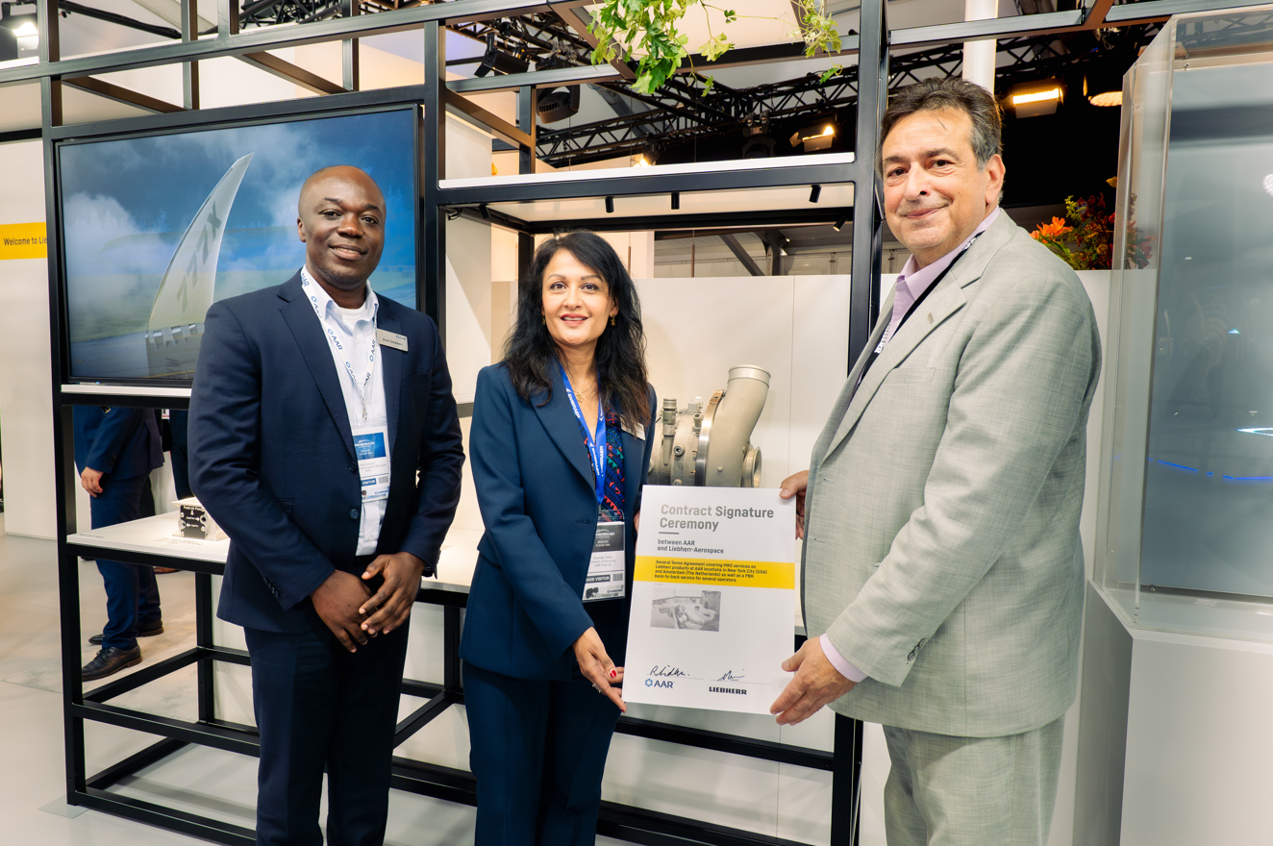
liebherr-general-terms-agreement-aar-copyright-liebherr
Ravinder Sidhu, Director of Sourcing (middle) and Emil Dickson, Senior Manager Business Development Repair & Engineering Services at AAR (left) as well as Alex Vlielander, Chief Customer Officer at Liebherr-Aerospace & Transportation SAS after the signature ceremony of the general terms agreement during Farnborough International Airshow 2024. – © Liebherr/Charles Plumey-Faye

Contact
Ute Braam
Head of Corporate Communication
Phone: +49 8381 / 46 - 4403
E-mail: ute.braam@liebherr.com

Published by
Liebherr-Aerospace & Transportation SAS
Toulouse / France
www.liebherr.com

