Press release

Al Askar takes delivery of 26 used Liebherr LTM cranes

⸺
Al Askar takes delivery of 26 all-terrain cranes with lifting capacities between 50 and 110 tonnes
All the cranes are refurbished in Germany
Liebherr used cranes deliver value retention and high performance
Al Askar has placed a major order for young used cranes – the Saudi Arabian company ordered 26 used mobile cranes in the medium lifting capacity class from Liebherr. Whilst it is primarily a mobile crane manufacturer, Liebherr is also an expert in refurbishing used cranes to customer specifications. Al Askar will receive high-quality, modern, powerful mobile cranes to strengthen its fleet.
Ehingen (Donau) (Germany), 26 July 2024 – Mohammed Al Askar, Owner of the Al Askar Group and Ibrahim Dewidar, Operations Manager visited together with Ajanthas Kumarathas Managing Director of Saudi Liebherr Co. the manufacturer's mobile and crawler cranes plant in Ehingen to place a huge order of used cranes in May 2024. Externally, the cranes look like new – freshly finished in brilliant white, as ordered by Al Askar. But it's not just the looks that are impressive - the inner values also leave nothing to be desired. Liebherr's experts have refurbished the cranes to meet all the customer’s specifications. “We trust Liebherr. We are proud to be able to add these devices to our fleet,” says Mohammed Al Askar and adds: “We can be sure that we will receive all the cranes from Liebherr in excellent condition and can get them to use immediately.”
The smallest of the 26 mobile cranes is an LTM 1050-3.1, the largest is an LTM 1110-5.1. As agreed with Al Askar, all the cranes will be fully refurbished in Germany before delivery to Saudi Arabia. Mohammed Al Askar explains: “These relatively new used cranes are equivalent to new cranes once they have been refurbished. Their performance data and technical features are up to date. We look forward to having all 26 LTM mobile cranes in our fleet by the end of the year.” Al Askar will use its cranes mainly for general industrial jobs.
“I believe that Liebherr cranes are always a benefit for us as crane operators,” continues Mohammed Al Askar. “Liebherr has impressed us with its intelligent safety systems, the excellent quality of all its components and all its production technology. Finally, the value retention and durability of Liebherr mobile cranes is an important factor.” Thanks to these points and the professional refurbishment work carried out by the manufacturer, used Liebherr mobile cranes are a genuine alternative to new cranes. They are also attractive due to their short lead times and the fact that they require lower finance. Liebherr has the largest selection of used cranes in the world. With technical expertise and decades of experience, its repair specialists spruce up the cranes to the level required by the customer.
The Al Askar Group, with over 700 employees, specialises in haulage and heavy load work. The company's fleet incorporates around 90 cranes and over 350 trucks. In Saudi Arabia, the local subsidiary Saudi Liebherr Company Ltd provides Al Askar with support in the form of an experienced, reliable customer and general service team for everything relating to Liebherr products.

About Liebherr-Werk Ehingen GmbH
Liebherr-Werk Ehingen GmbH is a leading manufacturer of mobile and crawler cranes. Its range of mobile cranes extends from 2-axle 35 tonne cranes to heavy duty cranes with a lifting capacity of 1200 tonnes and a 9-axle chassis. Its lattice boom cranes on mobile or crawler travel gear deliver lifting capacities of up to 3000 tonnes. With universal boom systems and extensive auxiliary equipment, they can be seen in action on construction sites throughout the world. The Ehingen site has a workforce of 5,000. An extensive, global service network guarantees the high availability of Liebherr mobile and crawler cranes. In 2023, the Liebherr plant in Ehingen recorded a turnover of 2.81 billion euros.
About the Liebherr Group – 75 years of moving forward
The Liebherr Group is a family-run technology company with a highly diversified product programme. The company is one of the largest construction equipment manufacturers in the world. It also provides high-quality, user-oriented products and services in a wide range of other areas. The Liebherr Group includes over 150 companies across all continents. In 2023, it employed more than 50,000 staff and achieved combined revenues of over 14 billion euros. Liebherr was founded by Hans Liebherr in 1949 in the southern German town of Kirchdorf an der Iller. Since then, the employees have been pursuing the goal of achieving continuous technological innovation, and bringing industry-leading solutions to its customers. Under the slogan ‘75 years of moving forward’, the Group celebrates its 75th anniversary in 2024.

Images
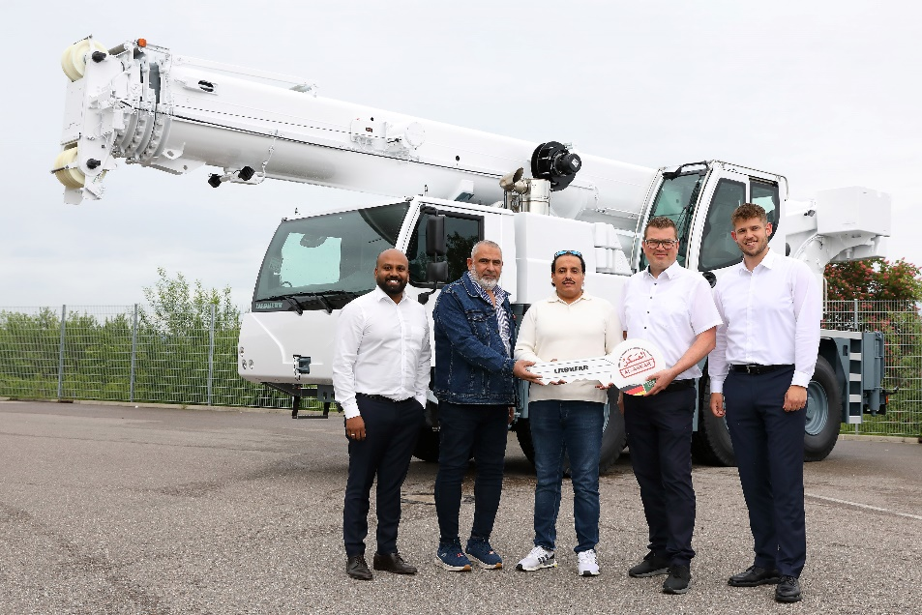
liebherr-al-askar-used-cranes.jpg
Crane handover in Ehingen – Al Askar takes delivery of one of the total of 26 Liebherr used cranes (from left to right): Ajanthas Kumarathas (Saudi Liebherr Co.), Ibrahim Dewidar, Mohammed Al Askar (both Al Askar Group), Bernd Rechtsteiner, Marius Kleck (both Liebherr-Werk Ehingen GmbH)

Contact
Wolfgang Beringer
Marketing and Communication
Phone: +49 7391/502 - 3663
Email: wolfgang.beringer@liebherr.com
Published by
Liebherr-Werk Ehingen GmbH
Ehingen (Donau) / Germany
www.liebherr.com

