Press release

Slurry wall construction in Naples

⸺

The company SAOS s.r.l. constructs slurry walls for infrastructure projects such as underground railways, road tunnels and high-speed railway lines throughout Italy. The duty cycle crawler crane HS 8130.1 with the cutter LSC 8-18 from Liebherr has been working on the "Parco San Paolo" underground station in the Campanian capital of Naples for over a year. A major benefit for the customer is the high flexibility of the carrier machine. In just a short time the duty cycle crawler crane can be converted, for example, to grab operation.

Nenzing (Austria), 30 July 2024 − The company SAOS s.r.l. is carrying out the slurry wall work for the construction of the "Parco San Paolo" underground station in Naples. “The slurry wall will be 1.2 metres thick and the bite length is 2.8 metres at a maximum depth of 52 metres. Altogether, 134 panels must be installed. We are using the HS 8130.1 with cutter LSC 8-18 and the HS 855 HD with hydraulic grab for this,” explains Antonio Mazzucco, Production Manager at SAOS s.r.l.

The slurry wall cutter from Liebherr is modularly designed meaning the customer can adapt the setup to suit the individual requirements and technical challenges. On the jobsite in Naples, SAOS s.r.l. are using the standard version with a total height of 12 metres. The high weight with low centre of gravity provides for maximum verticality and excellent control. For construction sites with limited height, the modular cutting frame can be shortened by 4 metres. A hydraulic turning device enables continuous alignment of the slurry wall cutter in the trench. This means all possible working positions are covered. The cutting direction can be corrected using 12 independently controllable steering flaps. The actual position of the flaps is displayed in real time on the monitor in the operator's cabin.

Complete Package

The carrier machine for the slurry wall cutter is the duty cycle crawler crane HS 8130.1. "This machine is ideally suited for use with slurry wall cutters as it is equipped with a powerful 570 kW Liebherr engine. Nevertheless, it produces only low emissions and little noise. This is perfect for working in urban areas like here in Naples," says Bertram Pfeifer, Application Specialist at Liebherr-Werk Nenzing GmbH. Liebherr offers the HS 8130.1 as carrier machine with slurry wall grab or cutter as well as the separation plant as a complete package. "Our application engineers can also support our customers with all technical challenges."

Liebherr offers the "4C-Power" pay-per-use business model for the cutter wheel drives, whereby the customer only pays for the cutter wheel drives per working hour. The advantage for the customer is that the costs are transparent and there are no surprises. The fee covers all costs of the cutter wheel drives - overhaul, service and transport are included. Liebherr also has the possibility of monitoring the cutter wheel drives via modem. The drive data makes it possible to react to any malfunctions at an early stage. By replacing the drives in good time, the costs for an overhaul can be reduced and the operating time on the construction site increased.

Jobsite film: <https://youtu.be/7aa3HH4yY1Q?si=seNYdngPz7lPwAPP>   
Animation slurry wall cutter: <https://youtu.be/rQKkMd9Xos8?si=zXffPGAe5iktsEm1>   
Animation slurry wall grab:<https://youtu.be/aL-PlTM28GE?si=P2jZMhhvk5sgGqtJ>   
4C-Power: <https://youtu.be/Bdp7udI8LtA?si=49vG1-_Uygg8qKxB>

About the Liebherr Group – 75 years of moving forward

The Liebherr Group is a family-run technology company with a highly diversified product programme. The company is one of the largest construction equipment manufacturers in the world. It also provides high-quality, user-oriented products and services in a wide range of other areas. The Liebherr Group includes over 150 companies across all continents. In 2023, it employed more than 50,000 staff and achieved combined revenues of over 14 billion euros. Liebherr was founded by Hans Liebherr in 1949 in the southern German town of Kirchdorf an der Iller. Since then, the employees have been pursuing the goal of achieving continuous technological innovation, and bringing industry-leading solutions to its customers. Under the slogan ‘75 years of moving forward’, the Group celebrates its 75th anniversary in 2024.

Images

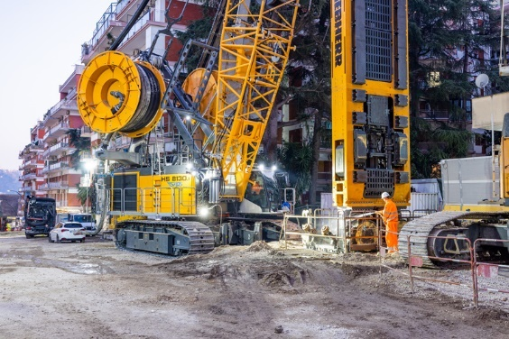

liebherr-cutter_1.jpg   
The powerful HS 8130.1 from Liebherr is ideally suited for slurry wall work.

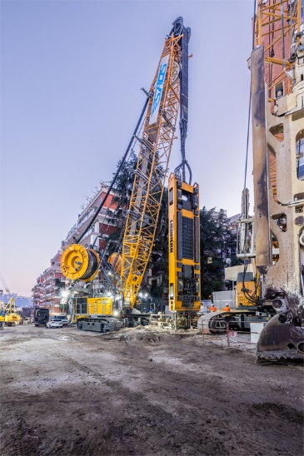

liebherr-cutter_2.jpg  
With the extended frame, the cutter has a total height of 12 metres.

Contact

Gregor Griesser  
Strategic Marketing and Communications  
Email: [gregor.griesser@liebherr.com](mailto:gregor.griesser@liebherr.com)

Wolfgang Pfister  
Head of Strategic Marketing and Communications  
Tel.: +43 50809 41-444  
Email: [wolfgang.pfister@liebherr.com](mailto:wolfgang.pfister@liebherr.com)

Published by

Liebherr-Werk Nenzing GmbH  
Nenzing/Austria  
[www.liebherr.com](http://www.liebherr.com)