Press release

Liebherr and Fortescue announce partnership for development of Autonomous Haulage Solution

⸺

Liebherr and Fortescue have announced a partnership to develop and validate a fully integrated Autonomous Haulage Solution (AHS).

The onsite validation of a fleet of four T 264 autonomous trucks, along with the AHS, is currently taking place at a purpose-built facility at Fortescue’s Christmas Creek mine site.

The AHS ecosystem will also include the development and validation of a Fleet Management System and Machine Guidance Solution.

This collaboration between Liebherr and Fortescue to deliver a fully integrated Autonomous Haulage Solution marks an expansion of the existing partnership between the two companies. The partnership began in June 2022, when the two companies announced their intention to build a zero emission haulage solution using Liebherr’s OEM experience and Fortescue’s fuel cell battery and battery-electric technology.

Colmar (France), 2 July 2024 – Building on the ongoing cooperative efforts between Liebherr and Fortescue, the two companies will further combine their areas of expertise to develop and validate an Autonomous Haulage Solution (AHS). The AHS will be integrated with the zero emission haul trucks that the companies are currently co-developing, with the aim to be the first AHS operating zero emissions vehicles globally.

In August 2023, Liebherr announced the deployment of a fleet of four T 264 autonomous trucks in Western Australia for onsite validation, which marked the next stage of Liebherr’s development of a new autonomy product for the mining industry. This onsite validation is currently taking place in partnership with Fortescue at its Christmas Creek mine site, in a purpose-built facility for validating zero emission and autonomous haulage technologies.

“With our teams now fully integrated, Liebherr is excited to formally announce our partnership with Fortescue to collectively develop and deploy our Autonomous Haulage Solution,” says Oliver Weiss, Executive Vice President, R&D, Engineering, and Production, Liebherr Mining. “Liebherr has always prioritised market-led product development and we are privileged to be partnering with Fortescue. Our collaborative efforts will be beneficial for not only Fortescue, but all customers who choose to implement Liebherr technology products on their sites.”

Building the future together

Liebherr and Fortescue’s partnership to develop and validate the AHS was formalised in March 2023. Since then, the team has finalised the definition of the System and is now developing the System’s extensive features and functionalities for validation.

As part of the AHS development, Liebherr and Fortescue will develop an integrated Fleet Management System and a Machine Guidance Solution, capable of being used independently on human-operated sites. Upon completion of system validation, the Autonomous Haulage Solution will be deployed across Fortescue mine sites.

“Our deep expertise in autonomous haulage that has come from operating over 200 diesel autonomous haul trucks across our mine sites, has enabled Fortescue and Liebherr to develop a Fleet Management System that uniquely targets efficiency and unlocks untapped capacity in our fleet,” said Dino Otranto, Fortescue Metals Chief Executive Officer. “The partnership with Liebherr has enabled us to jointly develop the Fleet Management Systems, which provide us with an OEM agnostic solution that can be integrated with any autonomous platform including trucks, drills, watercarts or any other heavy mining equipment. This critical technology puts our business in full control of our development priorities and roadmap.”

The AHS – including the Fleet Management System and Machine Guidance Solution – will also be made available to customers worldwide as part of Liebherr’s expanding technology portfolio.

“This development will allow us to offer the global market a complete Autonomous Haulage Solution including a fully integrated Fleet Management System and Machine Guidance Solution,” says Weiss. “These innovative technologies form part of our expanding range of technology products and are another step forward in our strategy to become a total solution provider for the mining industry.”

About Liebherr Mining

Liebherr Mining is one of 13 product segments within the wider Liebherr Group and has been designing, manufacturing, and supporting mining equipment for over 50 years. The company provides a full range of solutions, including high-quality trucks, excavators, and dozers along with technology and service products that help customers get the very best out of their Liebherr machines. Liebherr Mining is also working hard to offer low and zero emission options for all of its equipment to support customers as they embark on their decarbonisation journeys. The company has a global presence with over 4,400 employees in 70 countries around the world.

About the Liebherr Group – 75 years of moving forward

The Liebherr Group is a family-run technology company with a highly diversified product programme. The company is one of the largest construction equipment manufacturers in the world. It also provides high-quality, user-oriented products and services in a wide range of other areas. The Liebherr Group includes over 150 companies across all continents. In 2023, it employed more than 50,000 staff and achieved combined revenues of over 14 billion euros. Liebherr was founded by Hans Liebherr in 1949 in the southern German town of Kirchdorf an der Iller. Since then, the employees have been pursuing the goal of achieving continuous technological innovation and bringing industry-leading solutions to its customers. Under the slogan ‘75 years of moving forward’, the Group celebrates its 75th anniversary in 2024.

Images

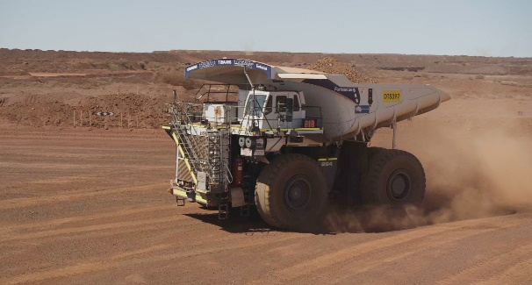

liebherr-AHS-T264-Fortescue-240dpi.jpg  
An autonomous T 264 during onsite validation at Fortescue’s Christmas Creek mine, Western Australia.

liebherr-T264-R9400-Fortescue-240dpi.jpg  
A perfect match: Liebherr machines working together in the Pilbara.

Contact

Swann Blaise  
Divisional General Manager: Marketing & Business Intelligence  
Phone: +1 757 928 2239  
E-mail: swann.blaise@liebherr.com

Published by

Liebherr-Mining Equipment SAS   
Colmar / France  
www.liebherr.com