Press release

Liebherr Crawler Dozers with LiReCon system deliver increased safety for Austrian Armed Forces

⸺
Two new Liebherr Crawler Dozers, equipped with the new LiReCon system, are providing active support for munitions clearance and disaster recovery for the Austrian Armed Forces.
Used in earthmoving operations at the Allentsteig military training ground, the system provides a vital boost to safety in areas containing multiple unexploded munitions.
The LiReCon remote control system allows for swift driver changeover in multiple shift operations, reducing machine downtime.
Most importantly, the driver is no longer physically tied to the machine, so that isolated or dangerous areas can be operated by remote control.
The military training ground of the Austrian Armed Forces, at Allentsteig in Lower Austria, was the location for a special handover in the summer of 2024. Under contract from the Federal Ministry of Defence, Liebherr supplied two Generation 8 PR 726 Crawler Dozers. The dozers were equipped with the new Liebherr Remote Control System (LiReCon). The delivery was backed up with extensive training and instruction on the new LiReCon system. With the deployment of these teleoperable Liebherr machines the Austrian Armed Forces can safely execute driverless operations both for disaster recovery and for clearance of areas containing multiple unexploded munitions at the military training ground.
Allentsteig (Austria), 14 January 2025 − A revolution in day-to-day operations using the Liebherr Remote Control System (LiReCon) for Crawler Dozers. Using the Liebherr teleoperation stand and a high-resolution video signal, this system opens up completely new operational horizons. The Crawler Dozer enables flexible remote control operation, opening up access to areas that are otherwise difficult to reach or hazardous to work. In addition to increasing safety, LiReCon also boosts driver comfort and productivity. But it is the ability of the system to work in dangerous environments that the Austrian Armed Forces found most impressive. This particularly applies to operational areas such as the military training ground in Allentsteig, with potential unexploded munitions present, or in disaster recovery work.
Equipped with cameras with real-time video transmission, the Liebherr system displays the work area with different views from varying angles. Microphones track the machine noises, and radio receivers and transmitters ensure a seamless connection to the remote driver. The main monitor uses a high-resolution video signal to provide a comprehensive view of the entire operational environment of the Crawler Dozer. The active person detection system, fitted as an option, identifies persons or obstacles in the work area, further increasing safety, to avoid accidents and prevent damage. LiReCon expands the operational horizons for Crawler Dozers.
“LiReCon offers an advanced solution for all Crawler Dozer operations. It ensures complete integration of the machine and visualisation of all relevant machine data. This includes the Liebherr teleoperation stand, which is a state-of-the-art operator station equipped with all the necessary controls and system information,” explains Hansjörg Nocker, Sales Manager at the Liebherr Telfs plant.
Teleoperation secures a safe working environment even under the most difficult conditions.
Based on their positive experience with the Liebherr PR 726 Crawler Dozers supplied in 2018, the Austrian Armed Forces collaborated with Liebherr Product Development to come up with a new operational design tailored to their needs. “The military training ground in Allentsteig is a zone with multiple unexploded munitions, and these have to be removed after military exercises. Up to now, clearing equipment with splinter protection and bulletproof glass has been used. Nevertheless, there was always a risk that the driver could be injured,” explains Lieutenant Colonel Dirk Wurth from the Office for Armaments and Defence Technology, Engineer Technology Department.
For this reason, the machine design was developed for teleoperation along with a container fully equipped for remote radio control of the machine. “Using this new design, we can effectively deploy equipment both for dangerous operations on the military training ground and difficult environments in disaster recovery. This also includes driverless support operations over the most difficult terrain, such as landslides or for road clearance with the army corps of engineers,” noted Lieutenant Colonel Wurth.
LiReCon advanced design: Highly flexible, compact and safe
LiReCon supports a range of remote control configurations. The on-site solution enables remote control of machines without visual contact, while relay stations are available as an option for extended operational range. The system can also be operated via an internet connection. Full integration into the machine control system, ensures that all current and future assistance functions can be used. LiReCon is therefore a foundation element for future device automation.
"LiReCon is notable for its modular design. With the latest upgrade, the control station is even more compact and transportable, enabling seamless integration into a range of plant infrastructures,” explains Hansjörg Nocker from the Liebherr Telfs plant. LiReCon is a universal cross-sector product. The intuitive user interface allows it to be readily integrated into different Liebherr machines, making it easy to switch between a wide variety of operating units.
In terms of safety, the system has an integrated emergency stop control to stop the machine dead in dangerous situations, as well as special safety functions for LiReCon machines. Data security for LiReCon is ensured by encrypted data transmission and monitored data packets. It also offers operator certification with various authorisation levels.

The all-round Liebherr assistant for day-to-day tasks - even with a driver on board
When you start to look at the many other product innovations on board these two new PR 726 G8s, you can clearly recognise the fundamental focus of development: the best possible grading performance and even greater driver comfort. With the benefit of Liebherr's standard Operator Assistance Systems and increased blade capacities, the Liebherr PR 726 G8 is suitable for both grading with millimetre-precision and for operations demanding pushing performance, for example in road clearance operations with the Austrian Armed Forces corps of engineers.
The electronically controlled operating hydraulics can be precisely tailored to the operating conditions and the driver's needs. As a result, the Liebherr development team have been able to integrate intelligent assistance functions and machine control systems. Liebherr Indicate provides the driver with detailed information about the absolute longitudinal grade and cross slope of the machine, together with all the parameters for the Liebherr Assistance Systems. The parameters for the desired terrain can be entered directly into the touch display as target specifications, which then flow in real time into the active blade control. In the case of the Austrian Armed Forces, this can also be carried out from the external LiReCon control station in the container. All Liebherr Assistance Systems have been developed as open systems with a focus on the future requirements of modern digital operations management.
“We are very pleased with the collaboration with Liebherr. Despite the major challenges for the Armed Forces and for Liebherr, the project plan proceeded exactly on track. The regular discussions and exchange of ideas contributed significantly to the continuous improvement process: A win-win situation for all involved and a mark of the strong mutual trust that was established,” commented Dirk Wurth in summarising this successful collaboration.

Link: Liebherr Crawler Dozers with LiReCon for Austrian Armed Forces (youtube.com)

About Liebherr Österreich Vertriebs- und Service GmbH
Liebherr Österreich Vertriebs- und Service GmbH, based in Puch near Hallein, is responsible for the sales and service of Liebherr construction machinery in Austria. This includes earthmoving and material handling machines, tower cranes, special foundation engineering machines, concrete technology, mobile and crawler cranes as well as rental and used equipment. The company also has branches in Vienna, Wels, Peggau, Klagenfurt, Telfs and Rankweil.
About the Liebherr facility in Telfs
Liebherr-Werk Telfs GmbH has been producing and developing an ever-growing range of construction machines with hydrostatic drives since 1976. The company is able to draw on the many years of experience of the Liebherr Group with this type of drive. Whether it’s Crawler Dozers or Loaders, Telescopic Handlers or Pipe Layers – construction machinery from Telfs is consistently designed to keep you on the move with the highest efficiency and cost effectiveness. Then, increasing efficiency as well as reducing fuel consumption and CO₂ emissions are a central focus. The latest computer-aided technologies are used both in development and production: from design engineering to welding robot processes, right through to computerised quality management.
The Liebherr Group
The Liebherr Group is a high technology company, in family ownership, with a diversified portfolio of products. The company is one of the largest construction machinery manufacturers in the world. But it also offers a range of high quality, high customer benefit products and services in many other areas. The Group currently consists of more than 150 companies across all continents. In 2023, it employed more than 50,000 people and generated a consolidated sales turnover of over €14 bn. Liebherr was founded by Hans Liebherr in 1949, in Kirchdorf an der Iller in southern Germany. From inception, the goal of the employees has been to delight their customers through novel contribution to technological progress and advanced technology solutions.

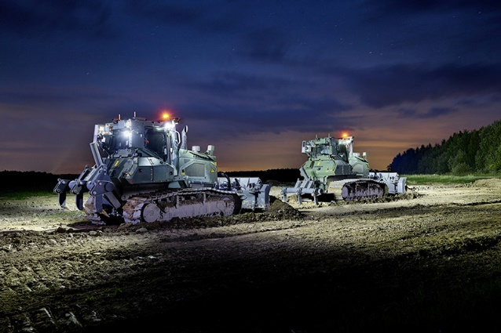
Images

liebherr-pr-726-einsatz-beim-bundesheer-1.jpg
The two new PR 726s with LiReCon from the Austrian Armed Forces during night time teleoperation.

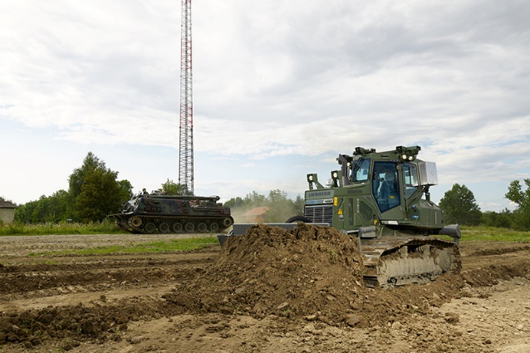

liebherr-pr-726-einsatz-beim-bundesheer-2.jpg
Additional operational support for rescue and disaster recovery: teleoperated PR 726 Crawler Dozer at the Allentsteig military training ground.

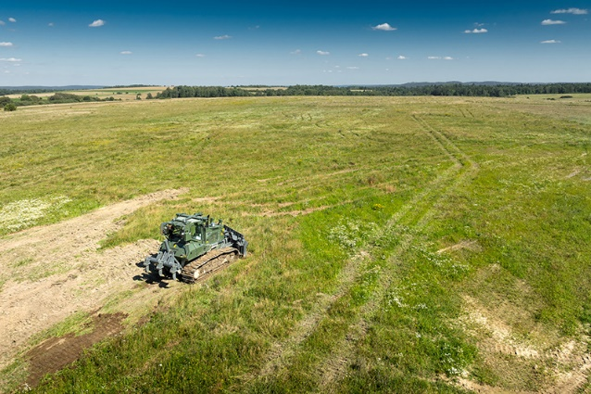

liebherr-pr-726-einsatz beim-bundesheer-3.jpg)
The Allentsteig military training ground in Lower Austria is a unique natural area in Europe with rare flora and fauna due to its isolated location.
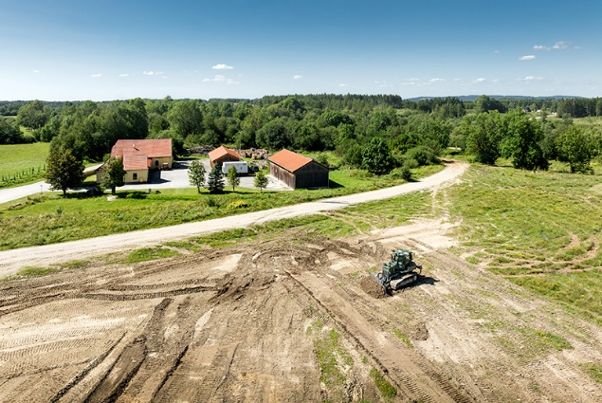

liebherr-pr-726-einsatz beim-bundesheer-4.jpg
PR 726 Crawler Dozer under remote control at the Allentsteig military training ground.
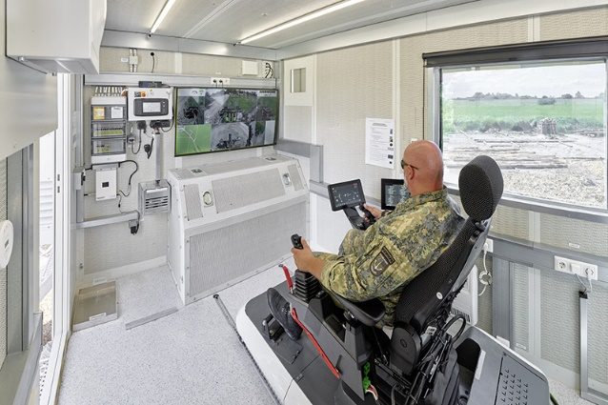

liebherr-pr-726-einsatz beim-bundesheer-5.jpg)
Everything safely in view: The Liebherr PR 726 Crawler Dozer can be controlled with LiReCon under teleoperation from the control station in the container.

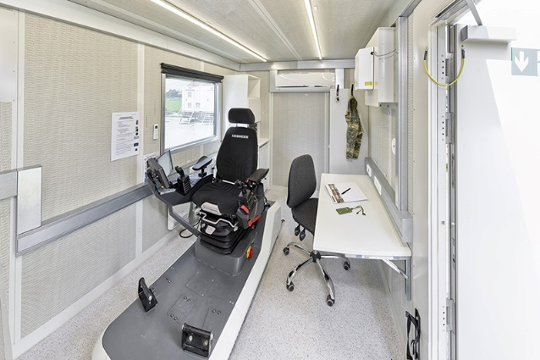

liebherr-pr-726-einsatz beim-bundesheer-6.jpg
The fully equipped Workplace of the Future - container with the new LiReCon for Crawler Dozers.
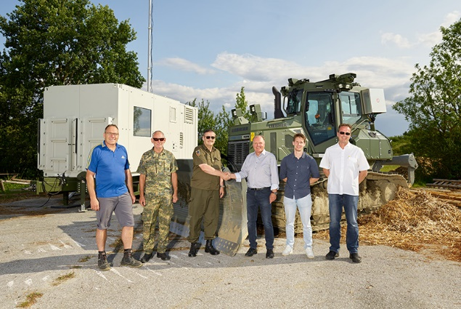

liebherr-pr-726-einsatz beim-bundesheer-7.jpg)
Representatives from the Austrian Armed Forces (left) and the Liebherr sales team (right) at handover and training welcoming their new collaborative operational design.
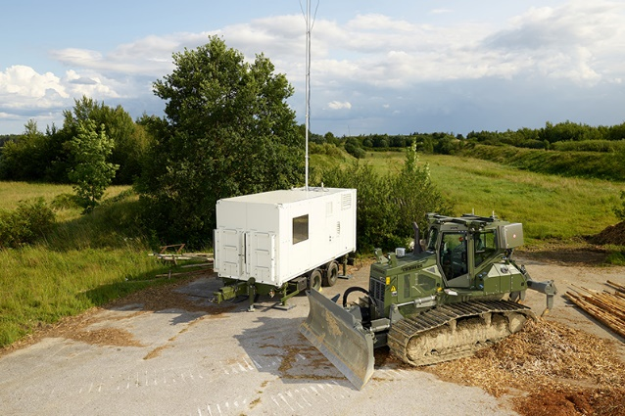

liebherr-pr-726-einsatz beim-bundesheer-8.jpg
Unique duo − the new Liebherr PR 726 Crawler Dozer with LiReCon trailer.

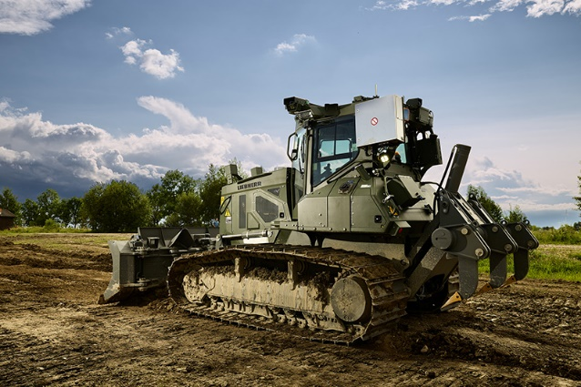

liebherr-pr-726-einsatz beim-bundesheer-9.jpg
The new PR 726 for the Austrian Armed Forces can be remotely controlled via teleoperation.

Contact
Elisabeth Weitgasser
Marketing Manager Distribution and Service
Telephone: +43 664 1039654
E-Mail: elisabeth.weitgasser@liebherr.com
Published by
Liebherr Österreich Vertriebs- und Service GmbH
Puch bei Hallein/ Austria
www.liebherr.com

