Press release

Anniversary: Liebherr produces its 10,000th XPower wheel loader

⸺

A great success story: The 10,000th XPower wheel loader rolls off the production line in Bischofshofen

The power-split XPower travel drive combines the advantages of both hydrostatic and mechanical drives

Long-standing partnership with transmission manufacturer ZF Friedrichshafen AG as one of the factors for success

Anniversary wheel loader L 580 XPower goes to the BERGER Group in Passau

The Liebherr plant in Bischofshofen is celebrating a major milestone in its history with the production of its 10,000th XPower wheel loader. At the heart of the machine, standard on all Xpower models, is a power-split travel drive produced by Liebherr’s trusted partner ZF Friedrichshafen AG. The 10,000th XPower wheel loader is therefore not only a cause for celebration for Liebherr, but also for ZF. The anniversary wheel loader will be put into service at the BERGER Group, which is also based in Passau.

Bischofshofen (Austria), May 2025 – The long-standing partnership between Liebherr-Werk Bischofshofen GmbH and ZF Friedrichshafen AG has reached an impressive milestone: The 10,000th XPower wheel loader with power-split transmission from ZF rolled off the production line, an impressive testament to the successful collaboration between the two companies. To mark this happy anniversary, representatives from ZF’s Passau site travelled to Bischofshofen to celebrate the long-standing and successful partnership. Representatives of the BERGER Group, who took delivery of their machine in person, and representatives of the Beutlhauser Group, who sold the XPower wheel loader to the customer, were also present at the anniversary event.

Liebherr-Werk Bischofshofen GmbH is a long-standing development partner of driveline specialist ZF. Drawing on its decades of experience in developing wheel loaders, Liebherr actively contributed to the development of the power-split transmission so that the manufacturer could optimise it for the requirements of the XPower travel drive. “The transmission from our partner ZF is a key component of the drivetrain in our XPower wheel loaders. With an impressive total of around 64,000,000 operating hours already clocked up by XPower models, this transmission has proven its exceptional robustness,” explains Gerhard Pirnbacher, Head of Quality Management at the Liebherr plant in Bischofshofen. Daniel Härter, Senior Vice President of Industrial Technology at ZF’s Passau site, adds: “We would like to congratulate Liebherr on its 10,000th XPower wheel loader and are delighted that our transmission is playing a part in the XPower success story.”

**From Bischofshofen back to Passau**

The anniversary wheel loader – with special decals and a hand-signed transmission by ZF employees – is going to the BERGER Group in Passau, where it will be put into service near the ZF transmission plant in a BERGER Rohstoffe GmbH quarry in the Bavarian Forest. Matthias Neidhardt, Managing Director of BERGER Rohstoffe GmbH, Johannes Urmann, Authorized Signatory, and Michael Gruber, Technical Division Manager, travelled to Bischofshofen to receive their new wheel loader at the handover ceremony. During the ceremony, Dr. Herbert Pfab, Managing Director of Technology at the Liebherr plant in Bischofshofen, presented the new owners with a symbolic key for the new XPower. The BERGER Group has already got 20 XPowers in operation and is delighted with the anniversary machine. "We value the handling, reliability and relatively low operating costs of our XPower machines. We are particularly pleased that a gearbox from our home region of Passau is installed in our new wheel loader," says Matthias Neidhardt. The BERGER Group also values its trusted partnership with Beutlhauser Group in Passau and the outstanding services it provides.

Maximum efficiency for every operation

For around a decade, the XPower wheel loaders L 550 to L 586 have established themselves as pioneers when it comes to fuel efficiency and robustness. Its power-split drive system combines both hydrostatic and mechanical drives. The hydrostatic travel drive is the most efficient drive type for short loading operations, while the mechanical drive is the most powerful and economical for long distances and uphill driving. “This means that the XPower offers the highest efficiency in material pick-up and transport, as well as optimum acceleration and maximum performance in all loading cycles – even over long distances,” explains Pfab.

The power-split ZF transmission is responsible for combining the two drive paths. It operates variably and adjusts the mixing ratio of the two drive paths continuously and automatically. This means that the wheel loader always operates at maximum power and efficiency, regardless of the application. With the expertise of its development partner ZF, Liebherr can integrate the transmission perfectly into the entire drive system and match all components precisely to each other. The result is enormous fuel savings compared to conventionally powered wheel loaders.

**Robust, durable, and reliable**

As the power is developed through the interaction of two drive paths, enormous robustness is achieved. The load is thus distributed across both drive paths and the components have a significantly longer service life. Operators can work without interruptions, increasing operational reliability. The robust design and use of high-quality materials also ensure that the gearboxes operate reliably even under extreme conditions. This is a decisive advantage for customers who depend on high machine availability and low maintenance costs.

**About ZF**

ZF is a global technology company. The company supplies highly developed mobility products and systems for passenger cars, commercial vehicles, and industrial technology. With a comprehensive product range, ZF primarily supplies vehicle manufacturers, mobility providers, and emerging companies in the transport and mobility sector. ZF electrifies vehicles in a wide range of categories and, with its products, contributes to reducing emissions, protecting the climate, and making mobility safer. In addition to the automotive sectors of passenger cars and commercial vehicles, ZF serves market segments such as construction and agricultural machinery, wind power, marine, rail technology, and test systems. In 2024, ZF achieved revenue of €41.4 billion with around 161,600 employees worldwide. The company is represented at 161 production sites in 30 countries.

**About the BERGER Group**

The BERGER Group is an owner-managed, medium-sized group of companies in the construction and building materials industry with its headquarters in Passau, Lower Bavaria. The construction markets in Germany, Austria, Poland, the Czech Republic and Slovakia are covered by branches and subsidiaries. The BERGER Group employs a total of 2,868 people. The Group develops and realises technically sophisticated construction solutions. In addition to building construction and road construction, its construction activities also focus on specialised civil engineering and structural engineering. The company's own construction materials and raw materials companies expand the range of services. The pillars of the Group include BERGER Bau SE, BERGER Beton SE and BERGER Rohstoffe GmbH.

About Liebherr-Werk Bischofshofen GmbH

Liebherr-Werk Bischofshofen GmbH develops, produces and sells wheel loaders from the Liebherr Group. The plant in Salzburger Land (Austria) has grown steadily over the decades thanks to sustainable innovations, creative solutions and high quality standards. The wheel loader range is constantly being expanded and includes models in different product groups: Compact loaders, stereoloaders, and mid-sized and large wheel loaders with impressive, innovative drive designs.

About the Liebherr Group

The Liebherr Group is a family-run technology company with a highly diversified product portfolio. The company is one of the largest construction equipment manufacturers in the world. It also provides high-quality, user-oriented products and services in a wide range of other areas. The Liebherr Group includes over 150 companies across all continents. In 2024, it employed more than 50,000 staff and achieved combined revenues of over 14 billion euros. Liebherr was founded by Hans Liebherr in 1949 in the southern German town of Kirchdorf an der Iller. Since then, its staff have worked tirelessly to impress their customers with sophisticated solutions and actively advance technology.

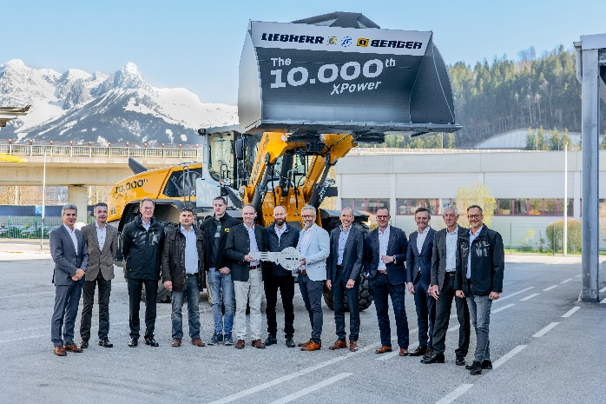Images

liebherr-10000-xpower-event.jpg  
Representatives from ZF, BERGER Group, and Beutlhauser Group travelled to Bischofshofen to celebrate this joyous anniversary.

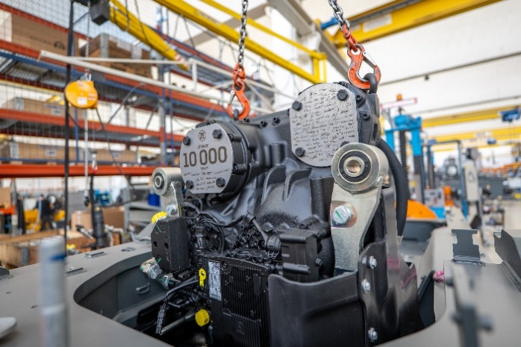liebherr-10000-xpower-transmission-zf.jpg  
The 10,000th transmission was signed by hand by the ZF workforce.

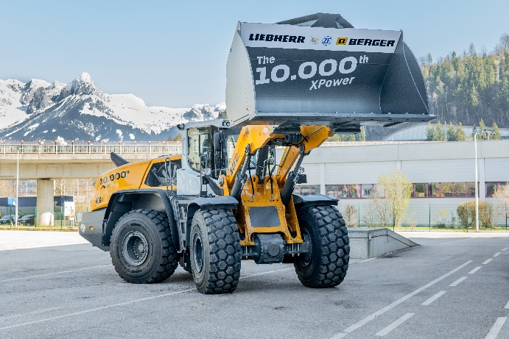

liebherr-10000-xpower-anniversary.jpg  
The 10,000th XPower wheel loader with specially labelled bucket at the Liebherr factory in Bischofshofen.

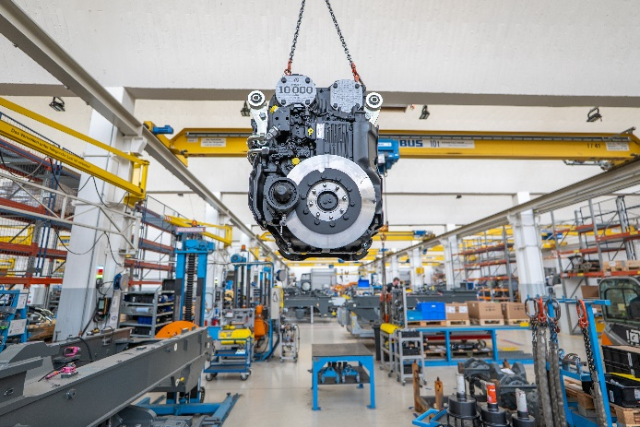

liebherr-10000-transmission-zf-xpower.jpg  
The power-split ZF transmission prior to installation in the XPower anniversary engine.

Contact

Anna Zögernitz  
Marketing and Public Relations  
Telephone: +43 50 809 12195  
Email: anna.zoegernitz@liebherr.com

Published by

Liebherr-Werk Bischofshofen GmbH  
Bischofshofen/Austria  
[www.liebherr.com](http://www.liebherr.com)