Press release

Fleet expansion: Liebherr LTM 1300-6.3 mobile crane for Guindastes Centro Oeste

⸺
LTM 1300-6.3 with 90-metre telescopic boom
300-tonne crane for maintenance work
Impressive quality and service from Liebherr
The Brazilian crane hire firm Guindastes Centro Oeste has added a Liebherr LTM 1300-6.3 mobile crane to its fleet. With a 90-metre-long telescopic boom, the 300-tonne crane has already proved its mettle on its maiden assignments and excelled at tough industrial maintenance work. Crucial factors in favour of the purchase of the new mobile crane included the quality and reliable customer service offered by Liebherr.
Ehingen (Donau) (Germany), 23 May 2025 – To further strengthen its market position as one of the leading crane service providers in Brazil, Guindastes Centro Oeste decided to purchase a new 300-tonne crane from Liebherr. The LTM 1300-6.3 was created especially for industrial maintenance work where flexibility, precision and safety are of crucial importance.
“Our focus lies on providing efficient solutions for critical work where time is a key factor for the success of our customers’ projects. The equipment is designed especially for complex industrial maintenance work. Fast and safe processes are crucial to ensuring the continuity of the production processes”, explains Diego Scopel, the owner of Guindastes Centro Oeste.
Strategic decision
Following a comprehensive analysis in cooperation with Liebherr, Guindastes Centro Oeste opted for the LTM 1300-6.3. “This model offers our customers the greatest added value”, says Scopel, adding: “Thanks to the 90-metre telescopic boom, maintenance work can be carried out efficiently. The 6-axle crane also impresses with its fast and easy handling during setup − with both of these factors contributing to time savings and increased efficiency.”
Proven in action
At the crane handover, the team from Guindastes Centro Oeste were given in-depth technical training in order to ensure maximum performance and safety while operating the crane. The crane operator already uses the LTM 1300-6.3 and it provides support for maintenance work in the steel, cellulose, paper and foodstuffs industries. “The high workload in the first few weeks shows that the investment was the right one and it highlights our ability to respond quickly to market demands”, says Scopel, happily.
Partnership with Liebherr: trust and reliability
The decision to purchase an LTM 1300-6.3 was based on the trust that Centro Oeste has in Liebherr’s high-quality products and services: “Our investment decisions are founded on aspects of reliability, technology and support. We appreciate Liebherr for the robustness of its machinery, the innovations it comes up with and the exceptional technical service it delivers. This partnership allows us to maintain the high standards that we have been offering our customers for 35 years”, concludes Scopel.

About Liebherr-Werk Ehingen GmbH
Liebherr-Werk Ehingen GmbH is a leading manufacturer of mobile and crawler cranes. Its range of mobile cranes extends from 2-axle 35 tonne cranes to heavy duty cranes with a lifting capacity of 1,200 tonnes and a 9-axle chassis. Its lattice boom cranes on mobile or crawler travel gear deliver lifting capacities of up to 3,000 tonnes. With universal boom systems and extensive auxiliary equipment, they can be seen in action on construction sites throughout the world. The Ehingen site has a workforce of 5,000. An extensive, global service network guarantees the high availability of Liebherr mobile and crawler cranes. In 2024, the Liebherr plant in Ehingen recorded a revenue of 3.19 billion euros.
About the Liebherr Group
The Liebherr Group is a family-run technology company with a highly diversified product portfolio. The company is one of the largest construction equipment manufacturers in the world. It also provides high-quality, user-oriented products and services in a wide range of other areas. The Liebherr Group includes over 150 companies across all continents. In 2024, it employed more than 50,000 staff and achieved combined revenues of over 14 billion euros. Liebherr was founded by Hans Liebherr in 1949 in the southern German town of Kirchdorf an der Iller. Since then, the employees have been pursuing the goal of achieving continuous technological innovation, and bringing industry-leading solutions to its customers.

Image
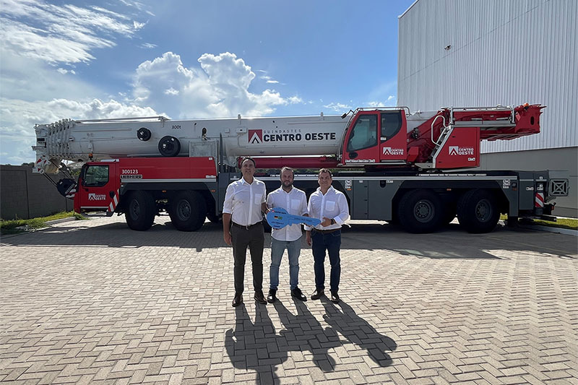
liebherr- handover-ltm-1300-6-3-centro-oeste.jpg
Centro Oeste Guindastes takes delivery of a Liebherr LTM 1300-6.3 mobile crane (from left to right): Fabio Azevedo (Liebherr Brasil LTDA), Diego Scopel (Centro Oeste Guindastes) and Rene Porto (Liebherr Brasil LTDA).

Contact
Wolfgang Beringer
Marketing and Communication
Tel: +49 7391 / 502-0
Email: wolfgang.beringer@liebherr.com
Published by
Liebherr-Werk Ehingen GmbH
Ehingen (Donau) / Germany
www.liebherr.com

