Press release

Liebherr Turkey and DSI agree on major dozer deal

⸺

* 130 new Liebherr dozers for Turkish State Hydraulic Works (DSİ)
* Contract includes PR 756 and PR 736 Litronic crawler tractors
* Machines to be manufactured at the Liebherr plant in Telfs, Austria
* Agreement continues long-standing collaboration between DSİ and Liebherr

**Liebherr Turkey has reached an agreement with Turkey’s General Directorate of State Hydraulic Works (DSİ Devlet Su İşleri) for the delivery of 130 crawler tractors. The order includes 120 units of the PR 756 Litronic and 10 units of the PR 736 Litronic. Production of the machines will begin shortly at the Liebherr facility in Telfs, Austria.**

Telfs (Austria), 28 July 2025 − This agreement marks another milestone in the long-standing partnership between Liebherr and DSİ. The Turkish authority has relied on Liebherr dozers for over a decade to support its large-scale infrastructure initiatives. In 2014, DSİ invested in 130 PR 754 Litronic machines, many of which are still in daily use today.

**High-performance crawler tractors for demanding applications**

The PR 756 Litronic is designed for tough, high-volume applications. With an operating weight of 35,400 to 43,000 kg and an engine output of 260 kW / 353 HP, it delivers powerful pushing performance with outstanding efficiency. Its hydrostatic drive enables smooth and precise control, while minimising fuel consumption and component wear.

For more compact and detailed work, the PR 736 Litronic offers a versatile solution. With an operating weight between 21,200 and 25,500 kg and an engine power of 160 kW / 217 HP, it is ideal for slope work, fine grading, and site support tasks where agility and precision are essential.

Both models are equipped with intuitive control systems, a comfortable and ergonomic operator environment, and integrated assistance systems to enhance productivity and safety. GPS readiness and fuel-saving ECO modes come as standard, supporting intelligent and efficient machine operation.

**Reliable partners in national infrastructure**

DSİ will deploy the new fleet in a wide range of hydraulic and environmental projects across Turkey, including large-scale earthmoving for dam and canal systems, sediment removal, flood basin shaping, and access road construction.

In addition to these core applications, the machines will also be used for cleaning riverbeds, preventing floods and overflows, constructing irrigation channels, and, when necessary, responding to forest fires. Their versatile functionality makes them indispensable for both planned infrastructure works and emergency interventions.

Thanks to over two decades of collaboration with Liebherr, DSİ has developed a strong institutional understanding of crawler tractor operations. The authority operates a fleet of approximately 2,000 heavy-duty machines and employs highly experienced personnel capable of running a single unit for up to 20–25 years. Their operators are well-trained, technically proficient, and supported by a robust corporate memory, making DSİ one of the most capable public machinery users in Turkey. The selected blade types, 6-way blade on the PR 736 and angle blade on the PR 756, have proven to be effective across Turkey’s diverse terrain, offering flexibility for various job types and challenging conditions.

Liebherr also supports DSİ with operator training, technical service, and spare parts supply to ensure long-term operational readiness. This delivery further solidifies the successful cooperation between the two organisations and Liebherr’s role in supporting Turkey’s infrastructure growth with reliable, high-performance machinery.

**About DSİ**

DSİ is Turkey’s official authority on water management. Founded in 1954, the agency oversees the planning, construction, and operation of irrigation systems, dams, flood protection facilities, water treatment plants, and reservoirs. DSİ plays a key role in agricultural development, water security, and environmental protection across the country.

“With this new fleet, we are not only delivering high-performance machines, but also long-term support, training, and service to ensure DSİ’s success on the ground,” says Levent Çakar Ankara, Regional Manager, at Liebherr Turkey. “It’s a great example of how global engineering expertise and strong local collaboration can drive sustainable infrastructure development. “With this order, Liebherr-Werk Telfs reaffirms its role as a reliable partner in global infrastructure development, delivering machines that combine power, precision, and durability for critical applications around the world.

**About the Liebherr Group**

The Liebherr Group is a family-run technology company with a highly diversified product portfolio. The company is one of the largest construction equipment manufacturers in the world. It also provides high-quality, user-oriented products and services in a wide range of other areas. The Liebherr Group includes over 150 companies across all continents. In 2024, it employed more than 50,000 staff and achieved combined revenues of over €14 billion. Liebherr was founded by Hans Liebherr in 1949 in the southern German town of Kirchdorf an der Iller. Since then, the employees have been pursuing the goal of achieving continuous technological innovation, and bringing industry-leading solutions to its customers.

Images

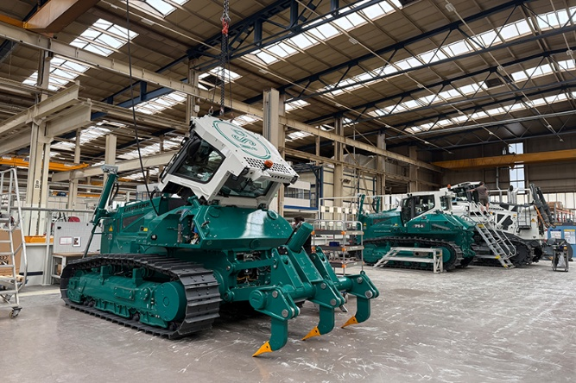

liebherr-DSi-Bulldozer-Factory1.jpg  
PR736 being built at Liebherr Telfs

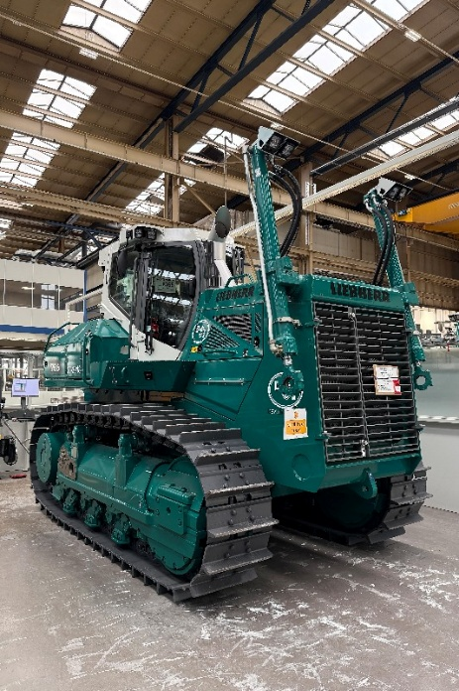

liebherr-DSi-Bulldozer-Factory2I.jpg  
PR756 being built at Liebherr Telfs.

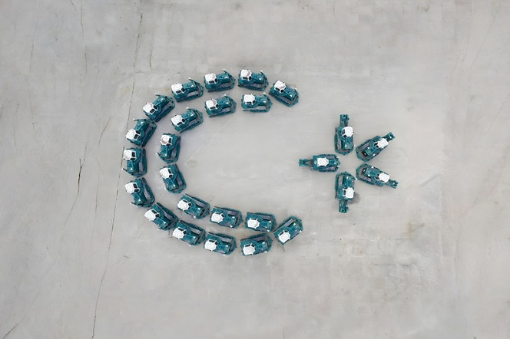

liebherr-DSi-Bulldozer-Flag.jpg  
Bulldozers arranged in the shape of the Turkish flag at Liebherr Telfs.

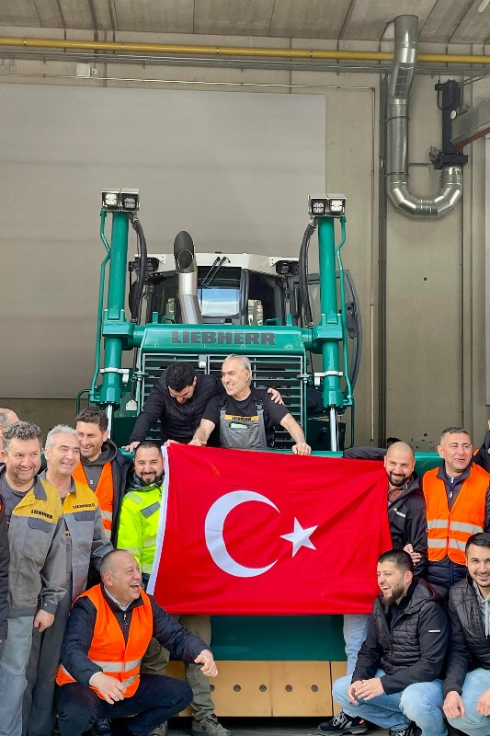

liebherr-DSi-coaching.jpg  
Turkish team during bulldozer inspection and training at Liebherr Telfs, proudly holding their national flag.

**Contact**

Thor Remmerde  
Marketing Manager PR & Content  
Telephone: +43 690 50064811  
Email: Thor.Remmerde@liebherr.com

**Published by**

Liebherr Werk Telfs GmbH  
Telfs / Austria  
[www.liebherr.com](http://www.liebherr.com)