Press release

Liebherr drives forward sustainable energy and infrastructure solutions for construction sites

⸺
Liebherr expands its portfolio in the field of digitalisation and sustainable energy management
The newly founded company, Liebherr Energy Solutions GmbH, combines the existing core competencies in the field of energy storage technologies, as well as energy planning and management software
The innovative portfolio is designed to further reduce energy consumption and CO₂ emissions on construction sites and to promote the electrification of construction and commercial vehicles
With the foundation of Liebherr Energy Solutions GmbH, Liebherr expands its portfolio in the field of digitalisation and sustainable energy management. The new company combines the existing core competencies in the field of energy storage technologies, as well as energy planning and management software. In the long term, Liebherr envisages to also provide respective energy services. The innovative portfolio is designed to further reduce energy consumption and CO₂ emissions on construction sites and to promote the electrification of construction and commercial vehicles.
Baden (Switzerland), February 17, 2026 – With the foundation of Liebherr Energy Solutions GmbH, Liebherr positions itself as a solution provider in the growing segment of the digitalisation-supported transformation from fossil-fuelled to battery-electric machines. Data-supported planning and IoT monitoring make these more efficient – and in some cases feasible at all.
Hardware, software and service under one roof
Liebherr Energy Solutions GmbH emerges from the Liebherr components product segment and focuses on energy storage technologies along with the corresponding in-house developed software solutions.
The mobile, battery-based energy storage system, Liduro Power Port, LPO for short, provides a stable and locally emission-free power supply for the entire construction site. Its high power density and compact design also enable efficient, flexible supply to machines and construction sites with a wide range of power requirements.
A valuable companion to the LPO is the browser-based Energy Planner software, which enables holistic planning of the power and energy requirements of a construction site in different construction phases. The tool helps site and fleet managers, electrical engineers and energy planners, as well as dispatchers with energy planning and setting up a construction site. In the future, active monitoring and partial control will also be possible due to an increasing number of smart consumers, storage devices and distributors.
Liebherr's innovative storage technology and electric construction machinery, together with the intelligent software and service solutions by Liebherr Energy Solutions, form the foundation for the electric construction site of the future.
The newly founded company combines two of Liebherr's core competencies and offers a comprehensive solution for more sustainable energy supply on construction sites. "The rapidly growing energy demand on construction sites and the associated transformation of the construction industry take the topic of electrification to a new level," explains Daniel Bachmann, managing director of Liebherr Energy Solutions GmbH. "This brings new complexity to the areas of planning, management and infrastructure. This is exactly where we come in, supporting construction site operators, planners and equipment suppliers in this transformation – efficiently, sustainably and with an eye to the future."
Rethinking energy: a benefit for our customers
The unique combination of powerful hardware, intelligent software and reliable energy services enables CO₂-neutral construction site operations. The LPO battery storage system supplies locally emission-free energy for heavy machinery, while an active energy management system ensures that electric construction machinery is always supplied with power when it needs it. With the Energy Planner, customers can determine energy requirements in advance, identify optimal grid connection points or design complete off-grid systems. This offers a high degree of planning reliability for a seamless construction site operation and future charging management. Together, these solutions enable a seamless transition to a fully electric machine fleet and allow to achieve the defined sustainability goals – with no compromise in performance. At the same time, the energy service can optimise energy procurement, enabling significant cost savings.
Another advantage of this holistic solution is an option to connect PV systems to the on-site battery storage units. This maximises self-consumption, stores surplus energy and ensures reliable operation, even when there is no sun.
A major competitive advantage thereby is the possibility of converting a depot for the electrification of an existing machine fleet with new business opportunities. Liebherr Energy Solutions GmbH supports the transformation of infrastructure and paves the way for electrification. "We enable companies to significantly contribute to the reduction of energy consumption and CO₂ emissions and jointly drive forward the electrification of construction and commercial vehicles," summarises Daniel Bachmann.
About the Liebherr Group
The Liebherr Group is a family-run technology company with a highly diversified product programme. The company is one of the largest construction equipment manufacturers in the world. It also provides high-quality, user-oriented products and services in a wide range of other areas. The Liebherr Group includes over 150 companies across all continents. In 2024, it employed more than 50,000 staff and achieved combined revenues of over 14 billion euros. Liebherr was founded by Hans Liebherr in 1949 in the southern German town of Kirchdorf an der Iller. Since then, the employees have been pursuing the goal of achieving continuous technological innovation, and bringing industry-leading solutions to its customers.
Image
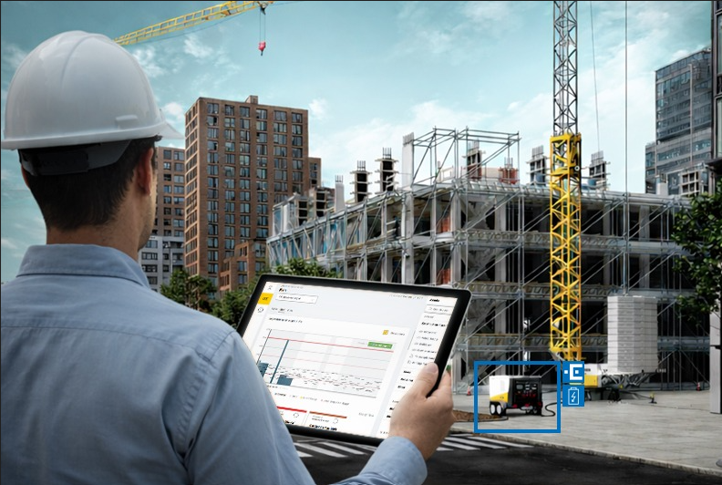
liebherr-rethinking-energy.jpg
The Liebherr Energy Solutions GmbH offers a holistic solution for a more sustainable energy supply of construction sites.
Contact
Alexandra Nolde
Senior Communication & Media Specialist
Phone: +41 56 296 4326
E-mail: alexandra.nolde@liebherr.com
Published by
Liebherr-Components AG
Baden / Schweiz
www.liebherr.com
Energy solutions - Liebherr

