Press release

Versatile networked Liebherr R 915 Compact G8, R 917 Compact G8 and R 920 Compact G8 crawler excavators are now available

⸺
A complete product range: developed for the requirements of modern construction sites
Maximum versatility and high flexibility in use
High performance and efficiency: ready for the job
Reliability, high availability and optimal cost control
Against a background of higher numbers of urban construction projects, the pursuit of productivity increases and a growing requirement for flexible machines, Liebherr is further expanding its compact excavator offer by introducing the generation 8. The R 915 Compact G8, R 917 Compact G8 and R 920 Compact G8 crawler excavator models have been developed to satisfy current requirements on building sites and the needs of the market at the same time. They exemplify compactness, performance and user comfort. The new product range is perfectly aligned with Liebherr’s commitment to provide structural and civil engineering companies with innovative, customer-focused solutions that help them meet the challenges of today's competitive construction industry.
Colmar (France), 26th June 2026 -The new R 915 Compact, R 917 Compact and R 920 Compact Generation 8 crawler excavator models presented at Bauma 2025 are now available. Developed and manufactured by Liebherr-France SAS in Colmar, the new models expand Liebherr’s compact excavator portfolio and have been designed to meet the evolving demands of modern construction sites. Positioned in the strategically important 15 to 20-tonne class, the Generation 8 compact range delivers a comprehensive solution for earthmoving, road construction, utility installation and urban construction projects.
Modern working environment with the emCAB operator's cab and INTUSI operating concept
The R 915 Compact G8, R 917 Compact G8 and R 920 Compact G8 crawler excavators feature the new emCAB operator's cab, which offers a modern, ergonomic working environment centred on operating efficiency. At its heart is the INTUSI concept which This enables intuitive, customizable operation and allows the operator quick access to the most important machine functions. The intelligent layout inside the operator's cab makes all relevant devices and the joysticks optimally accessible and intuitive to operative. This provides more comfort and reduces fatigue in daily work. The high-precision electric joysticks are ergonomically designed and ensure smooth, precise control of machine movements, even in challenging applications like lifting work. The interaction between human and machine has been simplified, improving the efficiency of the entire work cycle.
Focus on the product family’s youngest member: the R 917 Compact G8
The R 917 Compact G8 crawler excavator represents a completely new model. This machine shows how Liebherr tackles the burgeoning requirements of urban construction sites. An especially small tail swing radius of 1,700 mm makes efficient working possible even in tight spaces while at the same time ensuring greater safety in use. Thanks to the compact design, operators benefit from a high degree of flexibility along with optimal mobility on the construction site, as they can easily switch between different operating locations. The R 917 Compact G8 rounds off the compact excavator product range and, in terms of performance, occupies a position between the R 915 Compact G8 and the R 920 Compact G8. It is especially well suited to challenging lifting work and pipeline construction. With its high performance and flexibility, the R 917 Compact G8 is idealfor use on urban construction sites, where tight spaces are frequently encountered.
Designed for a variety of uses on construction sites
Thanks to the balanced and well-rounded machine design and a wide choice of attachments, these compact excavators are suitable for a multitude of applications and can carry out several tasks simultaneously. With the numerous attachments available and the hydraulic tools, these are genuinely multi-functional machines that ensure optimal organisation and simplify coordination on the construction site, as they enable a smaller number of machines to be used. This flexibility allows companies to improve their operational efficiency and increase their overall profitability.
High performance and efficiency: ready for the job
In an environment that constantly demands more productivity, the new generation offers performance that is ideally tailored to the requirements of modern construction sites. Optimised engine and hydraulic performance ensure quick, smooth working processes and guarantees high digging forces, torque and traction in daily use. The R 915 Compact G8 achieves 90 kW / 122 hp, the R 917 Compact G8 offers 100 kW / 136 hp, and the R 920 Compact G8 completes the model range with 110 kW / 150 hp. Optimised kinematics reduce the need to reposition the machine, improve precision and contribute to maximum productivity on the construction site.
For the challenges in the compact segment
The new R 915 Compact, R 917 Compact and R 920 Compact are designed to perform in demanding environments, particularly urban areas and construction sites where space is limited. Their compact dimensions, combined with high levels of performance, deliver the agility and power needed to maximise productivity. By combining a compact footprint with impressive digging performance, the machines achieve fast cycle times and excellent operating efficiency across a wide range of applications. The reduced tail swing radius, particularly on the R 915 Compact and R 917 Compact, further enhances manoeuvrability, making it easier to work safely and efficiently in confined spaces.
Reliability, high availability and optimal cost control
The new compact excavators are engineered for long-term durability combining a robust machine design with high-quality components developed for intensive use. This ensures reliable performance and dependable operation, even in demanding working environments. Ease of maintenance has also been a key focus, with service points readily accessible from ground level. This simplifies routine maintenance tasks, helping to minimise downtime and maximise machine availability. The result is a machine that not only delivers reliable performance throughout its working life but also helps reduce operating costs by increasing uptime and improving overall efficiency.
Networked machines for an optimal overview
Thanks to Liebherr’s digital solutions, operators and fleet managers can precisely monitor machine performance in real time and optimise daily operations through services such as MyLiebherr Maintenance and Performance. Intelligent fleet management provides greater transparency, supports informed decision-making and helps maximise profitability. The new compact crawler excavators are designed to support long-term technological development, featuring an open architecture that is ready for future assistance systems and digital innovations. By combining advanced connectivity with a future-ready machine platform, Liebherr is already addressing the evolving requirements of tomorrow’s construction industry.

About Liebherr-France SAS
Liebherr-France SAS, founded in 1961, is responsible for the development and production of crawler excavators for the Liebherr group of companies in Colmar, France. The current product programme includes around 30 crawler excavator models, from the R 914 Compact to the R 998 SME, for use in earthmoving work and quarries. Products also include a range of machines for special tasks such as demolition, material handling and maritime/tunnel applications, as well as large-capacity electric excavators. Crawler excavators with an operating weight of 14 to 100 tonnes are equipped with Liebherr engines with 90 to 420 kW output. Liebherr France SAS employs more than 1,250 people and generates a turnover of 534 million euros.
About the Liebherr Group
The Liebherr Group is a family-run technology business with a broadly diversified product programme. The company is one of the largest manufacturers of construction machinery in the world. However, it also offers high-quality, user-oriented products and services in many other areas. Today, the group comprises more than 150 companies on all continents. In 2025, it employed more than 55,000 people and generated a total consolidated turnover of over 14 billion euros. Liebherr was founded by Hans Liebherr in 1949 in Kirchdorf an der Iller, south Germany. Since then, the employees have pursued the goal of convincing their customers with sophisticated solutions and contributing to technological progress.

Images
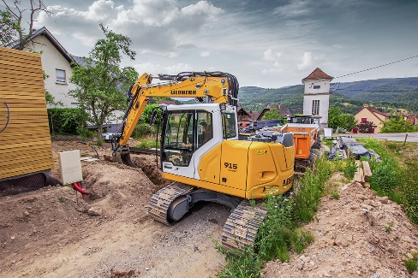
liebherr-r-915-compact-g8.jpg
The new R 915 Compact G8, R 917 Compact G8 and R 920 Compact G8 are built for use under difficult ambient conditions, especially in urban areas and on construction sites with restricted space.

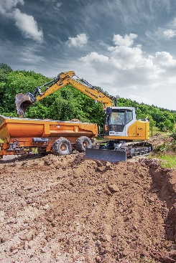
liebherr-r-917-compact-g8.jpg
The R 917 Compact G8 rounds off the compact excavator product range and, in terms of performance, occupies a position between the R 915 Compact G8 and the R 920 Compact G8.

Contact
Alban Villaumé
Marketing Manager
Telephone: +333 89 21 30 30
Email: alban.villaume@liebherr.com
Published by
Liebherr France SAS
Colmar, France
www.liebherr.com

