Press release

Water for a whole valley: Liebherr Fibre crane at work high in Val Trompia

⸺
The Liebherr 240 EC-B Fibre tower crane is currently one of the few Fibre-crane in operation in Italy
The crane supports construction of the new Bovegno Drinking Water Treatment Plant
Liebherr’s Fibre Rope Technology proves its value on the mountain site with limited space
In Bovegno, Italy, work is progressing on a new drinking water treatment plant designed to supply thousands of residents and businesses across the Val Trompia region. Handling the major lifting tasks on site is a Liebherr 240 EC-B Fibre tower crane, its fourth deployment and the first of its kind to arrive in the country.
Bovegno (Italy), 03. September 2026 – Facchetti Costruzioni has installed a Liebherr 240 EC-B Fibre tower crane on the construction site of the new Bovegno Drinking Water Treatment Plant, this marks another deployment of this Liebherr Fibre crane in Italy. The plant forms the third and final phase of the Val Trompia integrated water supply infrastructure project, which will provide a modern, safe and efficient drinking water supply for thousands of residents and local businesses in the region. The crane was supplied in collaboration with Niederstätter.
The crane is involved in all major lifting operations throughout the civil construction works. Its tasks include handling reinforcing steel, formwork systems, precast concrete elements, construction materials and equipment for the main building, the reinforced concrete water tanks and the auxiliary structures. The tanks are being built using the watertight reinforced concrete White Tank construction system, which integrates waterproofing directly into the concrete structure to ensure durability and long-term reliability.
Fibre-Rope Technology suited to a challenging mountain site
The construction site is located on the side of a mountain in an environmentally sensitive area. A medium-voltage power line runs only around 20 metres from the working area, requiring strict safety procedures throughout all lifting operations. Ground stabilisation using micropiles was carried out before excavation works began to ensure the stability of the site. Attention has also been given to integrating the new facility into the surrounding Alpine landscape through the use of timber and natural stone finishes. Fibre Rope Technology of the 240 EC-B Fibre offers increased lifting capacity, lower rope weight, simplified monitored maintenance and a longer service life than conventional steel ropes. Benefits that are particularly valuable under these site conditions according to Facchetti Costruzioni.

First mover for Fibre Rope Technology in Italy
Liebherr’s Fibre Rope Technology replaces the crane’s conventional steel hoist rope with a high-performance fibre rope, the result of more than 15 years of development and over 87,000 hours of testing on Liebherr’s test rig. Around 400 Fibre cranes are now in operation worldwide. The fibre rope is lighter than steel, can increase load capacities by up to 40 per cent and, thanks to an improved repair process, up to 90 per cent of rope damage can now be repaired directly on site rather than requiring a costly and time-consuming replacement. It is this combination of durability, repairability and reduced maintenance that convinced Facchetti Costruzioni to become the first company in Italy to introduce a Liebherr tower crane with Fibre Rope Technology, in collaboration with Niederstätter.
“The new Bovegno Drinking Water Treatment Plant is a strategic infrastructure project for our region, and we are proud to contribute to its construction. At Facchetti Costruzioni, innovation means investing in technologies that improve safety, efficiency and construction quality. Liebherr solutions allow us to tackle even the most demanding projects with reliability and precision and outstanding performance,” says Arch. Roberto Facchetti, Managing Director, Facchetti Costruzioni. "The long-standing partnership between Facchetti Costruzioni and Niederstätter is built on shared values and the tradition of two family-run companies, just like Liebherr.”
Facchetti Costruzioni is celebrating its 65th anniversary this year. Its most recent crane purchase, in 2025, was concluded personally by the company's founder at tower crane division in Liebherr Werk Biberach GmbH.
About the Liebherr Tower Cranes Division
More than seven decades of experience have made Liebherr a recognised specialist for lifting technology on all types of construction sites. The range of Liebherr Tower Cranes encompasses an extensive selection of high-quality tower cranes that are used worldwide. This includes fast-erecting, top-slewing, luffing jib and special-purpose cranes as well as mobile construction cranes. In addition to these products, Liebherr also offers a wide range of services that complete the company’s portfolio: Tower Crane Solutions, the Tower Crane Center and Tower Crane Customer Service.
About the Liebherr Group
The Liebherr Group is a family-run technology company with a highly diversified product programme. The company is one of the largest construction equipment manufacturers in the world. It also provides high-quality, user-oriented products and services in a wide range of other areas. The Liebherr Group includes over 150 companies across all continents. In 2025, it employed more than 55,000 staff and achieved combined revenues of over 14 billion euros. Liebherr was founded by Hans Liebherr in 1949 in the southern German town of Kirchdorf an der Iller. Since then, the employees have been pursuing the goal of achieving continuous technological innovation, and bringing industry-leading solutions to its customers.

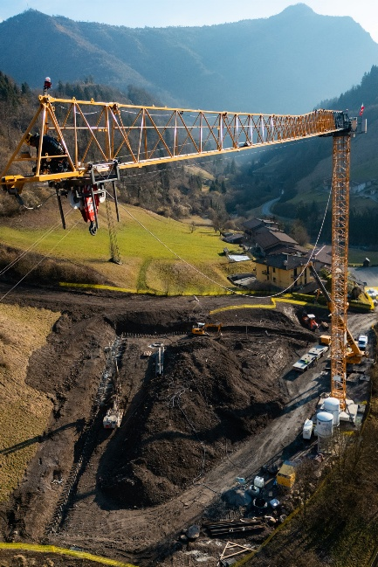
Images

liebherr-italy-val-trompia-01.jpg
The Liebherr 240 EC-B Fibre tower crane in operation at the construction site of the new Bovegno Drinking Water Treatment Plant.
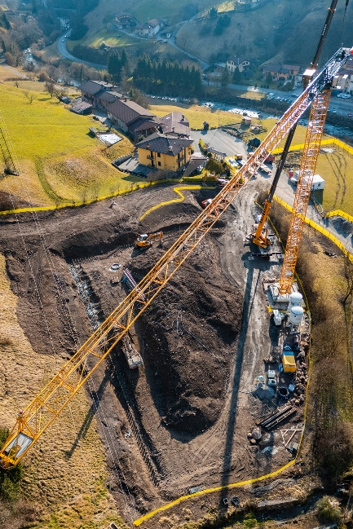

liebherr-italy-val-trompia-02.jpg
The plant forms the third and final phase of the Val Trompia integrated water supply infrastructure project in the Province of Brescia, Italy.

Contact
Shannon Korff
Marketing Specialist
Email: shannon.korff@liebherr.com
Published by
Liebherr-Werk Biberach GmbH
Biberach / Germany
www.liebherr.com

