Press release

Cadeler supports wind projects with Liebherr RL 2600

⸺

Cadeler A/S, a key supplier with the offshore wind industry, purchases new Ram Luffing Crane of type RL 2600 in support of growing offshore wind energy projects

The crane has a lifting capacity of 25 tonnes and a boom length of 45 metres, and will support the installation of wind turbines

The deck crane will be installed in early 2024 on the Wind Osprey vessel, and it is the first deck crane delivered directly to Cadeler by Liebherr

One of the leading Danish suppliers in the offshore wind industry, Cadeler, is supporting its Wind Osprey vessel with the latest RL 2600. This acquisition is part of the company’s upgrade initiatives through which by early 2024, its O-class vessels will be ready to support the next-generation of wind turbines. Cadeler visited Liebherr Rostock in March for a personal kick-off meeting, discussing project-specific developments of the deck crane, and touring the high-tech factory in which the crane is built. This project paves the way for a long and fruitful partnership.

Rostock (Germany), June 2023 – Building on the winds of change. Wind turbines are sizing up, as are demands for even larger cranes with higher specifications. Established in 2008, Cadeler has become one of the leading offshore wind industry companies. They have installed over 500 offshore wind turbines and equally as many foundations and are aiming to become the key supplier in the industry’s ongoing development. Among the essential assets of their work are two highly efficient Windfarm Installation Vessels, the Wind Orca and Wind Osprey. In addition to offshore wind farm installation, these vessels are very well suited for maintenance and decommissioning tasks within offshore wind.

The latest-generation Liebherr Ram Luffing Offshore Crane, the RL 2600, is part of the modernisation of Wind Osprey. With its focus on logistical support moving tools and smaller attachments, the deck crane is well positioned to support the vessel’s larger main crane. It has also been optimised to feature a small tail radius and the absence of machinery housing, which allows it to operate in confined space conditions and environments. Its 7 m3 cabin is highly ergonomic and ensures low-fatigue work for the operator. The combination of these features, as well as Liebherr’s high reliability and extensive service network, were among the main reasons why Cadeler chose Liebherr for its next-generation upgrades.

New crane to meet demands of the growing offshore wind energy industry

“Besides upgrading the lifting capacity of our Windfarm Installation Vessel main cranes to effectively handle larger and heavier wind turbines, we are also upgrading our equipment with innovative features and seeking strategic alliances with companies that will be with us in the long run. Liebherr fulfils our criteria for innovation, reliability, and service, and we are looking forward to working with them closely on our flagship projects,” says Jacob Heinricy Jensen, Chief Operations Officer at Cadeler.

The Wind Osprey’s main crane will also be upgraded. It will feature a lifting capacity of 1,600 metric tonnes at a radius of 40 metres, and a main hook able to reach 160 metres above the main deck. The Liebherr RL 2600 will replace an older cylinder luffing deck crane, and it is primed to support the installation of larger wind turbines for years to come.

“Our new partnership with Cadeler marks a remarkable opportunity for us to work with a leading provider in the wind energy industry,” says Stefan Schneider, Global Application Manager General Purpose Offshore Cranes. “This is a synergistic foundation for us in which we provide reliable products for Cadeler, while learning from our collaboration to further innovate our technologies to accommodate future industry growth. We look forward to a long and fruitful collaboration.”

The latest generation of the RL 2600

The RL series is distinguished by its particularly lightweight and compact design. The cranes are primarily used for maintenance and supply work on both fixed and floating offshore installations, particularly in the wind power industry and the oil and gas sector. Another special feature of the new RL crane series is the innovative cabinet inside the slewing column. The technology behind this innovation is called “EXpressure,” the world’s first explosion-proof Ex d cabinet that safely releases explosion pressure. It has been developed by Liebherr partner R. Stahl AG. The crane can also be ex-certified (through ATEX and IECEx).

About Liebherr-MCCtec Rostock GmbH

Liebherr-MCCtec Rostock GmbH is one of the leading European manufacturers of maritime handling solutions. The product range includes ship, mobile harbour and offshore cranes. Reach stackers and components for container cranes are also included in the product portfolio.

About the Liebherr Group

The Liebherr Group is a family-run technology company with a highly diversified product portfolio. The company is one of the largest construction equipment manufacturers in the world. It also provides high-quality and user-oriented products and services in a wide range of other areas. The Liebherr Group includes over 140 companies across all continents. In 2022, it employed more than 50,000 staff and achieved combined revenues of over 12.5 billion euros. Liebherr was founded in Kirchdorf an der Iller in Southern Germany in 1949. Since then, the employees have been pursuing the goal of achieving continuous technological innovation, and bringing industry-leading solutions to its customers.

About Cadeler A/S

Cadeler A/S is a key supplier with the offshore wind industry for installation services and operation and maintenance works that provides marine and engineering operations to the offshore wind industry with a strong focus on safety and the environment. Cadeler’s reputation as provider of high-quality offshore wind support services, combined with an innovative vessel design, positioning the company to deliver premium level services to the industry. As a company, Cadeler continues to pursue new levels of efficiency, pushing beyond the current boundaries of the supply chain. Cadeler enables and facilitates the global energy transition towards a future built on renewable energy. Cadeler is listed on the Oslo Stock Exchange (ticker CADLR).

Images

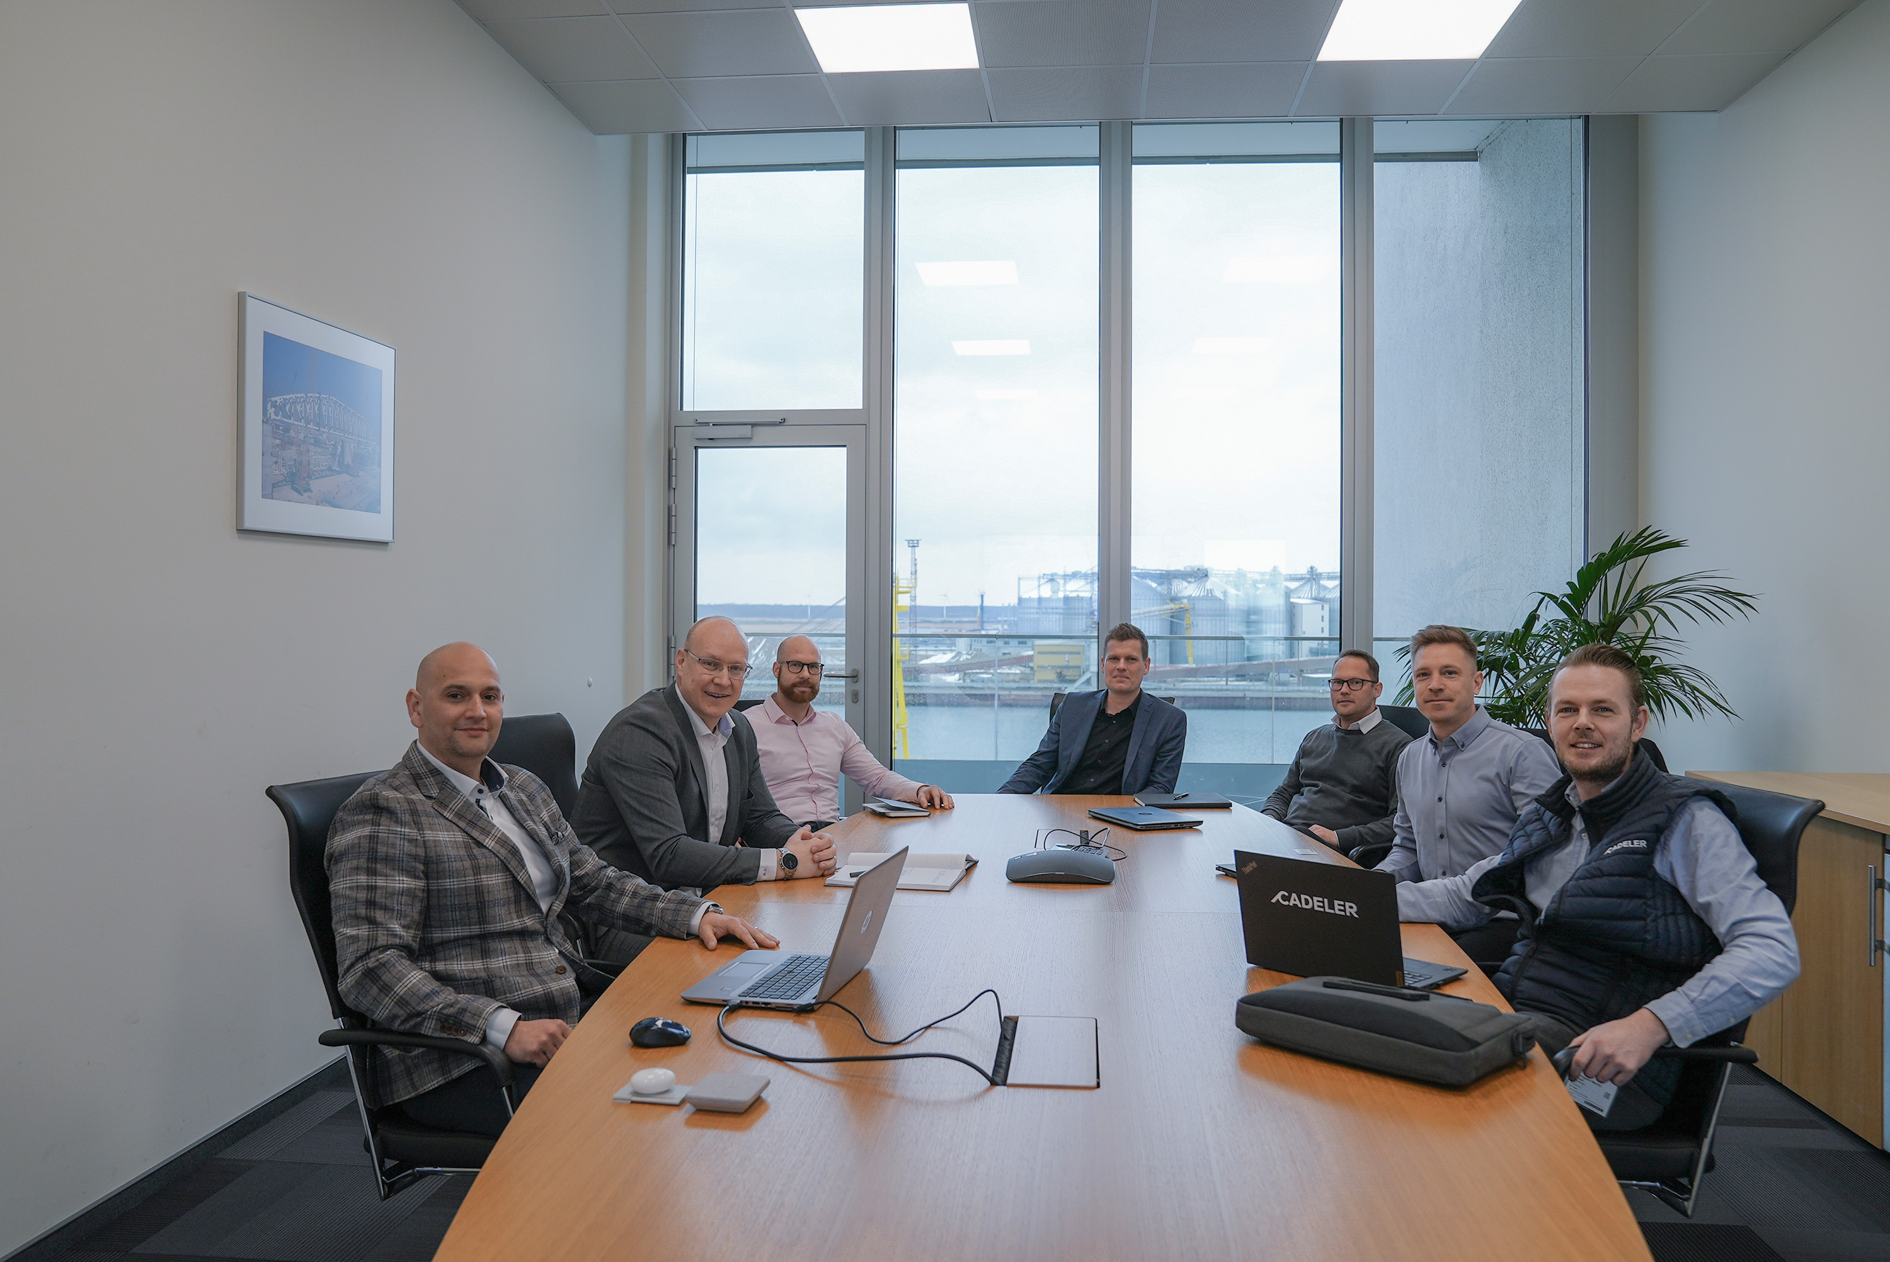

liebherr-cadeler-rl2600-offshore-1.jpg  
Cadeler visited Liebherr Rostock for a kick-off meeting to discuss crane design details, and tour the factory in which the crane is being built (f.l.t.r.: Ilie Toma, Project Manager at Liebherr; Gregor Levold, General Manager Sales - Offshore, Ship and Port Cranes at Liebherr; David Möller, Design Engineer at Liebherr; Matti Basan, Senior Sales Manager General Purpose Offshore Cranes at Liebherr; Marc Findeisen, Head of Customer Service Offshore Cranes at Liebherr; Jacob Grønvald Nielsen, Crane & Heavylift Specialist at Cadeler; Michael Strandgaard Merrild, Technical Superintendent at Cadeler).

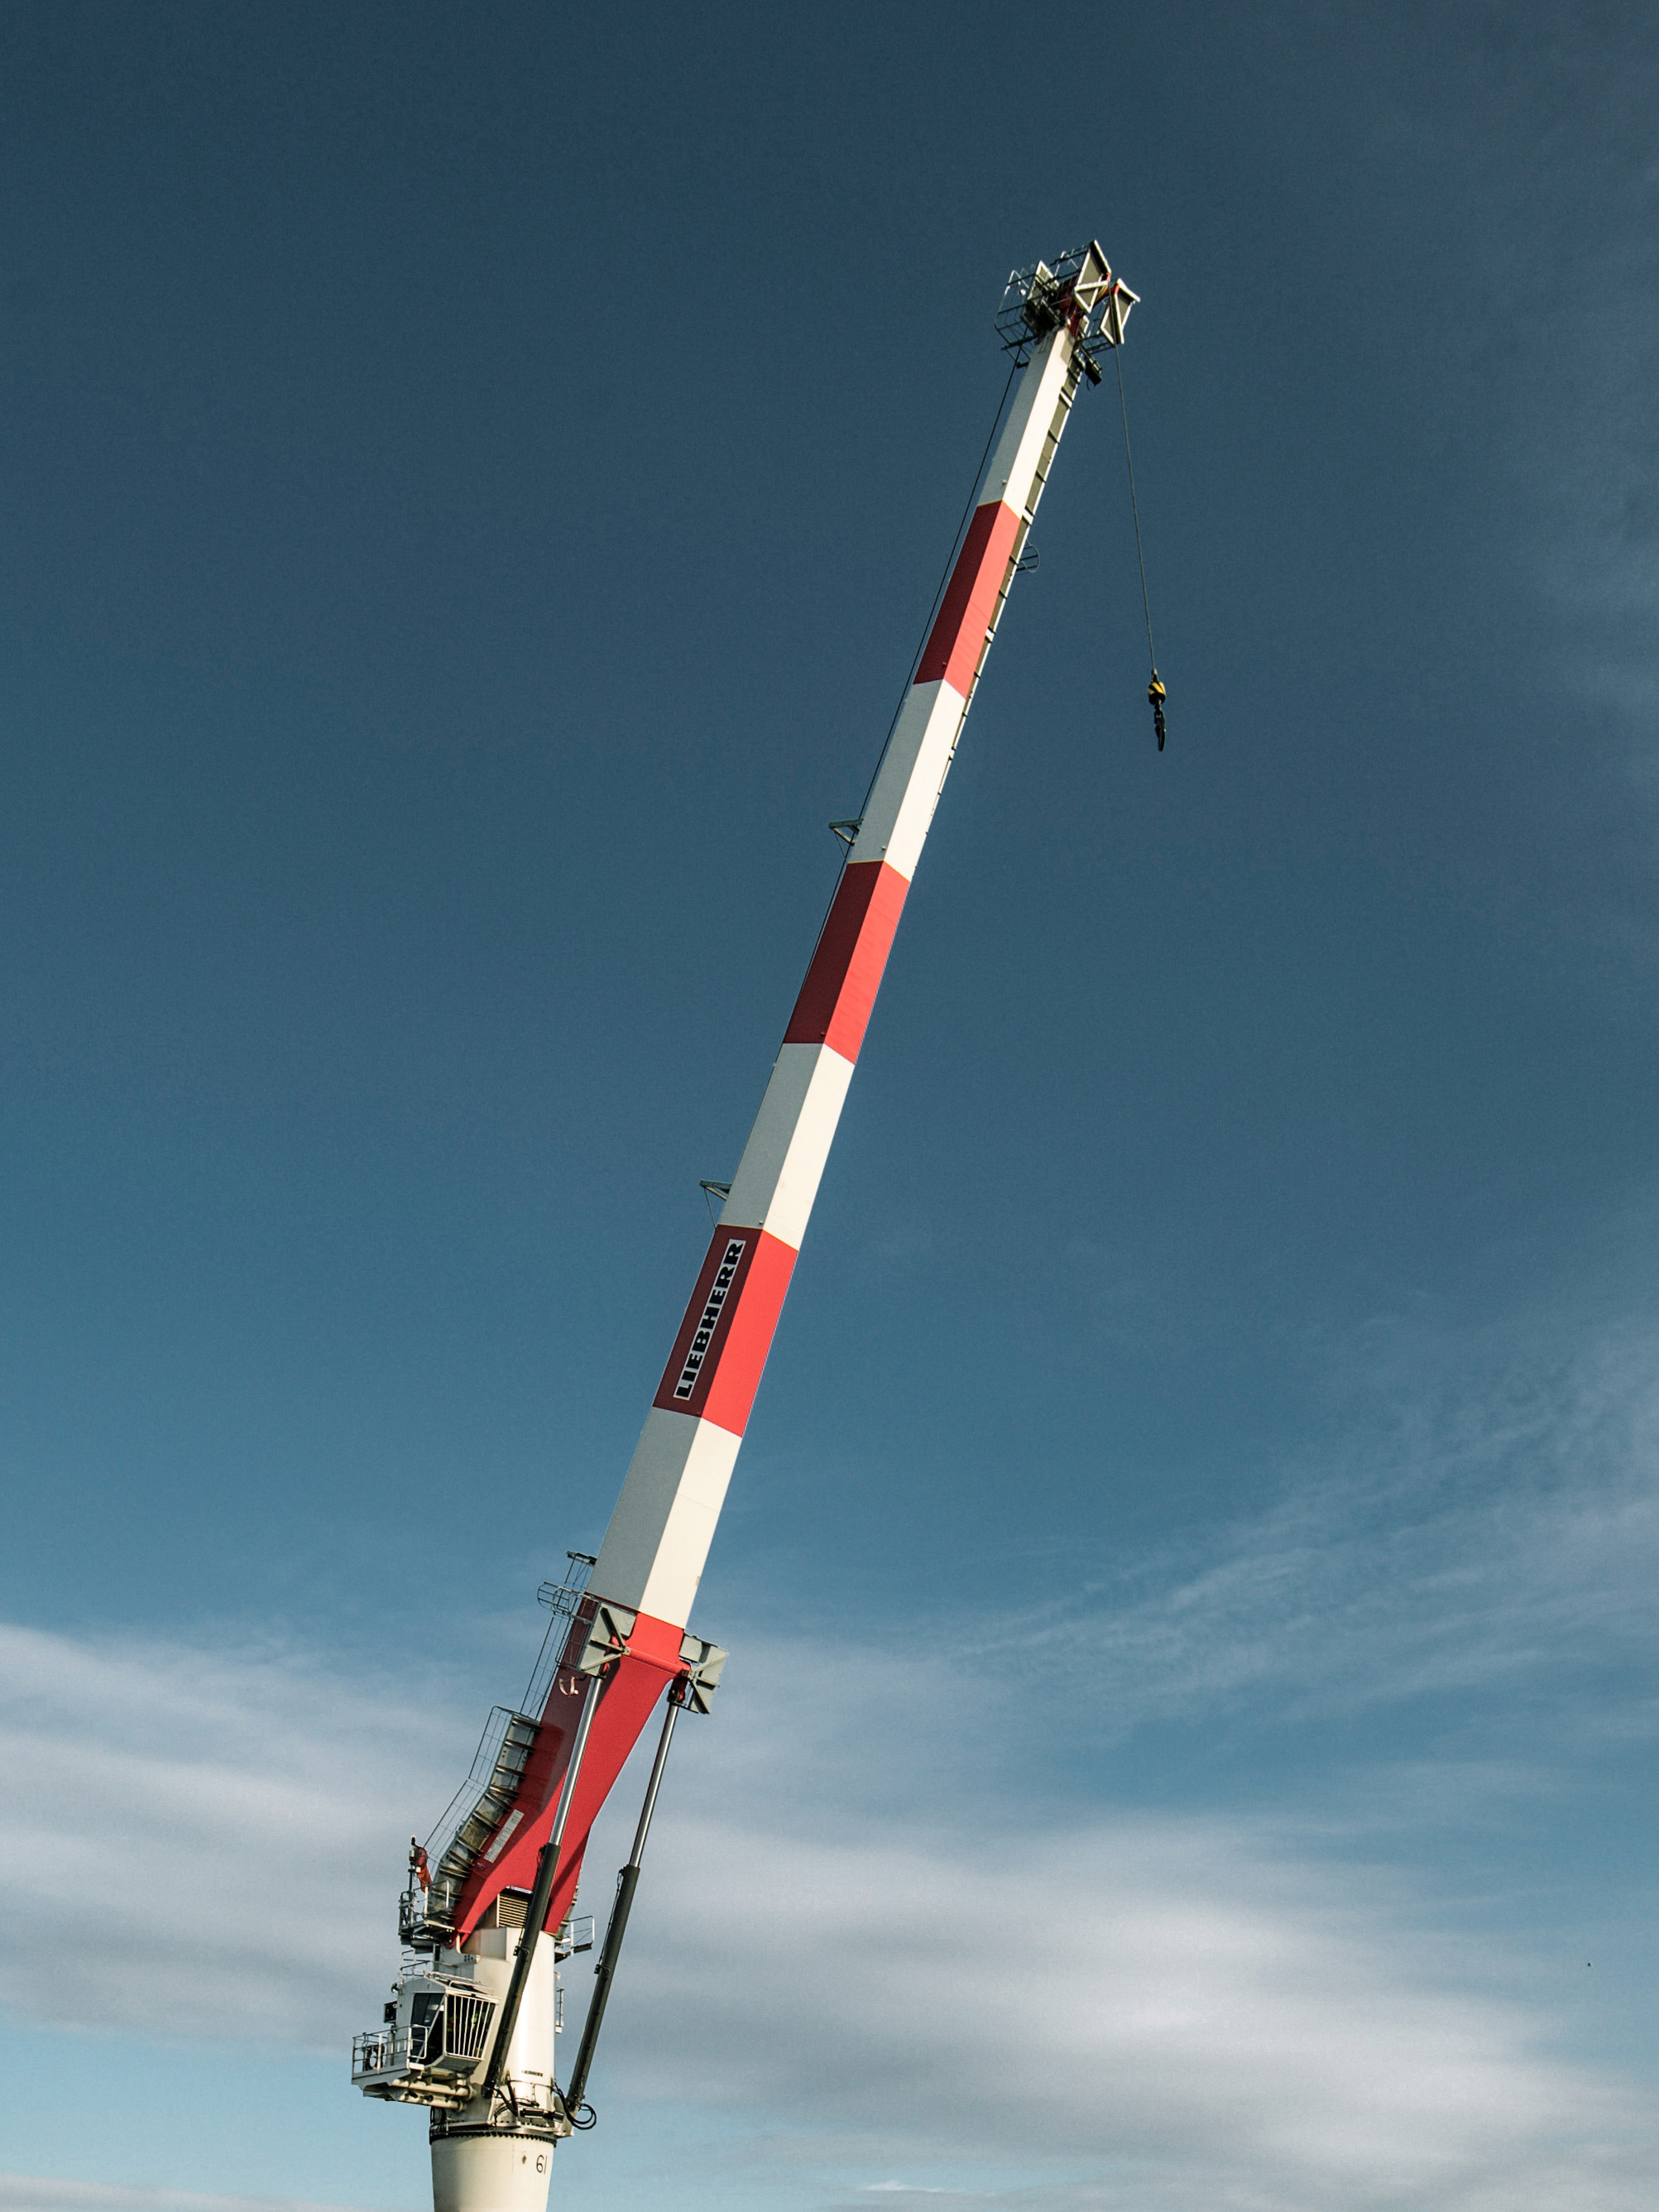

liebherr-cadeler-rl2600-offshore-2.jpg  
Ideally suited for logistical support and maintenance due to its weight-optimized and compact design, Cadeler is investing in the new RL 2600 for its next-generation upgrades of their “Wind Osprey” Windfarm Installation Vessel.

Contact

Philipp Helberg

Head of Marketing - Maritime Cranes

Tel: +49 381 60065020

Email: philipp.helberg@liebherr.com

Published by

Liebherr-MCCtec Rostock GmbH

Rostock / Germany

www.liebherr.com