Press release

Hack expands crane fleet with Liebherr LTM 1110-5.1

⸺

Good utilisation in the 5-axle class requires another crane

LTM 1110-5.1 offers high mobility and flexibility with strong performance

**Hack Schwerlastservice GmbH has taken delivery of a new LTM 1110-5.1 mobile crane. With the Liebherr 110-tonne crane, the Neuwied-based company is expanding its fleet. The good order situation in the 5-axle range required an additional crane in this class. Hack decided on the LTM 1110-5.1 because it combines powerful lifting capacities and a long telescopic boom with high mobility and flexibility.**

Ehingen (Donau) (Germany), 2 August 2023 - "We needed an additional 5-axle crane in our fleet. The LTM 1110-5.1 will expand our Koblenz branch and fits very well between our 100-tonne cranes and the LTM 1150-5.3. With a twelve-tonne axle load, it can carry 13.4 tonnes of ballast. That is a very good value. This allows us to use the LTM 1110-5.1 particularly economically, as it does not need a separate vehicle for counterweight for many tasks," explains company owner Udo Hack.

Liebherr has designed the LTM 1110-5.1 in such a way that ten-tonne axle loads and a total weight of less than 48 tonnes can be achieved by simply removing ballast. This variant brings significant advantages in terms of approvals and route permits. A quick-change system for the ballast plates guarantees maximum flexibility during changeover.

"We plan to use the LTM 1110-5.1 for general crane work, such as lifting prefabricated concrete parts, assembling air conditioning units, lifting swimming pools into the garden or assembling construction machinery," says Hack. At 60 metres long, the telescopic boom of the LTM 1110-5.1 is one of the longest in its crane class. In addition, a 10.8 to 19-metre folding jib is available, which can also be adjusted hydraulically between 0° and 40 ° as an option. The 110-tonner reaches a maximum hook height of up to 91 metres.

Hack Schwerlastservice GmbH operates several branches from Düsseldorf via Eifel and Westerwald to Frankfurt, among others for construction crane rentals and assemblies as well as repairs. Mobile folding cranes, towing and recovery services, industrial assembly with special electric cranes, working platforms and heavy transport are also part of the company portfolio.

The crane fleet consists of over 36 mobile cranes, the majority of which are machines from the Liebherr factory in Ehingen. Founded as a family business in 1959 by Werner Hack Senior and his wife Apollonia, the company has been steadily expanded and is now run in the second generation by the siblings Irene, Werner and Udo Hack.

**About Liebherr-Werk Ehingen GmbH**

Liebherr-Werk Ehingen GmbH is a leading manufacturer of mobile and crawler cranes. Its range of mobile cranes extends from 2-axle 35 tonne cranes to heavy duty cranes with a lifting capacity of 1200 tonnes and a 9-axle chassis. Its lattice boom cranes on mobile or crawler crane chassis deliver lifting capacities of up to 3000 tonnes. With universal boom systems and extensive additional equipment, they can be seen in action on construction sites throughout the world. The Ehingen site has a workforce of 4,300. An extensive, global service network guarantees the high availability of Liebherr mobile and crawler cranes. In 2022, the Liebherr plant in Ehingen recorded a turnover of 2.37 billion euros.

About the Liebherr Group

The Liebherr Group is a family-run technology company with a widely diversified product range. The company is one of the largest manufacturers of construction machines in the world. However, it also supplies high quality, user-focused products and services in many other sectors. The group currently comprises more than 140 companies based in every continent of the world. In 2022, it had a workforce of over 50,000 and recorded a consolidated total turnover of more than 12.5 billion euros. The company was founded in 1949 in Kirchdorf an der Iller in southern Germany. Since then, its aim has been to win customers by supplying high quality solutions and to contribute to technological progress.

**Image**

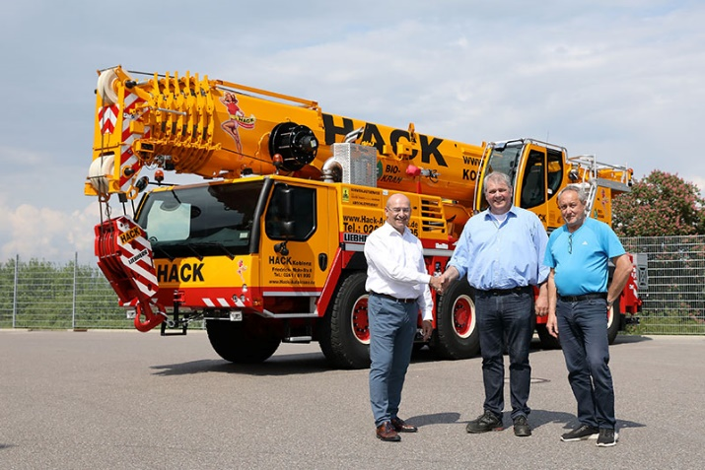

lwe-ltm1110-5.1-hack.jpg  
Crane handover in Ehingen: (left to right) Erich Schneider (Liebherr-Werk Ehingen GmbH), Udo Hack, Andreas Hannemann (Hack Schwerlastservice GmbH)

**Contact**

Wolfgang Beringer  
Marketing and Communication  
Phone: +49 7391/502 - 3663  
Email: wolfgang.beringer@liebherr.com

**Published by**

Liebherr-Werk Ehingen GmbH  
Ehingen (Donau) / Germany  
www.liebherr.com