Press release

Cost-efficient crane operation with mobile construction cranes from Liebherr

⸺

Hybrid power concept: Local emission-free operation possible

Use of site electricity significantly more cost-efficient than running on diesel

HVO fuel for travel possible straight from the factory

The days when construction site machines could only run on diesel are over. Liebherr’s mobile construction cranes are no longer limited to fossil fuels. HVO, an alternative fuel, can be used for travel from one location to the next. Site electricity or a mobile battery-based energy storage system are options for supplying power once the crane arrives at its destination.

Biberach (Germany), 9 November 2023 – Liebherr’s mobile construction cranes are taxi cranes, moving from one site to the next. They are quick and easy to erect and operate; only one person is needed for the job. The use of alternative fuels like HVO is possible for travelling from site to site. Both the superstructure and undercarriage can be powered by this fossil-free alternative.

Crane operation without diesel engine possible

The mobile construction crane can be operated in electric mode using site electricity instead of its diesel engine. This hybrid power concept enables the crane to operate locally with zero emissions and very little noise – an advantage when working in residential areas or on night-time construction sites. Using site power makes crane operation significantly more cost-efficient. Over a year, this results in only 10 percent of the operating costs associated with use of a diesel engine.

If there is insufficient or no on-site power available, Liebherr's mobile battery-based energy storage system Liduro Power Port (LPO) is able to take over supply, so that hybrid or all-electric construction machines can be operated and charged locally with zero emissions. A diesel-powered generator is a further available option.

Existing cranes can be powered by HVO

The alternative fuel HVO (hydrotreated vegetable oils) can be used to power cranes in its pure form or mixed with diesel to any required ratio. Fuel for Liebherr machines comes from food industry waste; palm oil isn't used. By reducing exhaust gases, HVO helps to limit global greenhouse gas emissions. The fuel is fully compatible with all engine components.

About the Liebherr Tower Cranes Division

More than seven decades of experience have made Liebherr a recognised specialist for lifting technology on all types of construction sites. The range of Liebherr Tower Cranes encompasses an extensive selection of high-quality tower cranes that are used worldwide. This includes fast-erecting, top-slewing, luffing jib and special-purpose cranes as well as mobile construction cranes. In addition to these products, Liebherr also offers a wide range of services that complete the company’s portfolio: Tower Crane Solutions, the Tower Crane Center and Tower Crane Customer Service.

About the Liebherr Group

The Liebherr Group is a family-run technology company with a highly diversified product portfolio. The company is one of the world's largest manufacturers of construction machinery. It also offers high-quality, user-oriented products and services in multiple other areas. Today, the group consists of more than 140 companies across all continents. In 2022, it employed more than 50,000 people and achieved combined revenues of over 12.5 billion euros. Liebherr was founded in 1949, in Kirchdorf an der Iller in southern Germany. Ever since then, the company’s employees have been committed to satisfying customers with advanced solutions and to helping drive technological progress.

Ein Bild, das Rad, draußen, Landfahrzeug, Fahrzeug enthält.
Images

liebherr-mk-88-4-1-01.jpg  
Narrow roads aren't a problem for Liebherr’s agile MK 88-4.1. By using HVO, it can reach its destination with lower exhaust emissions.

Ein Bild, das Himmel, Wolke, draußen, Kran enthält.

liebherr-mk-88-4-1-02.jpg  
Liebherr’s mobile construction cranes can operate with local power and without carbon emissions thanks to their hybrid power concept.

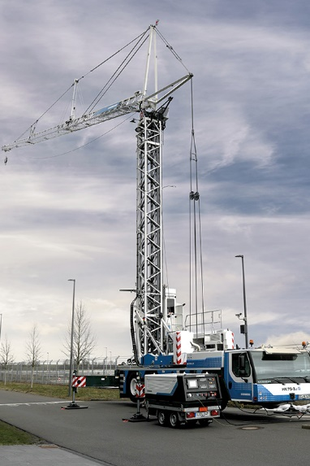

liebherr-mk-liduro-03   
The perfect match: a mobile construction crane and the Liduro Power Port (LPO) mobile battery-based energy storage system, both from Liebherr.

Contact

Astrid Kuzia  
Communication Specialist  
Phone: +49 7351 / 41 – 4044  
E-mail: astrid.kuzia@liebherr.com

Published by

Liebherr-Werk Biberach GmbH  
Biberach / Germany  
www.liebherr.com