Press release

Compact crane for vast country: LJP takes delivery of a another Liebherr LTC 1050-3.1   
⸺

Les Constructions LJP procures second LTC 1050-3.1

Impressive compactness and elevating cab

LJP operates machines from various Liebherr product ranges in its fleet

**The Canadian company Les Constructions LJP is an expert in concrete formwork. It ensures it receives optimum quality and service from its suppliers. LJP buys construction and mobile cranes exclusively from Liebherr. In October, the management took delivery of an LTC 1050-3.1 compact crane at the manufacturer's plant in Ehingen. It is now the second of this type in the LJP fleet.**

Ehingen (Donau) (Germany), 6 December 2023 – Company owner Sylvain Côté travelled to Germany with his son and nephews to officially take delivery of the LTC 1050-3.1 at Liebherr's site: "We've had our first LTC 1050-3.1 for around a year. It is one of our favourite cranes because it is so compact. Sometimes no other crane fits. The LTC can do the jobs of larger cranes because its dimensions allow it to get closer to the load. We also appreciate the elevating cab because you simply have a better view at this height. That's why we decided to purchase another LTC 1050-3.1."

Sylvain Côté is proud of his company, which now employs over 400 people and has an excellent reputation for complex and high formwork in particular: "When I took over the small company from my father in 1991, which he had founded in 1975, times were very tough. There was a recession at the time, so I had to sell my house to keep the company. I started with my hands and heart. My motivation was to create a unique company. I realised that I needed better equipment than my competitors and I knew that Liebherr builds the best products."

Côté bought his first Liebherr tower crane in 2008, and today LJP has 19 in its fleet. In 2017, Côté also decided to purchase mobile cranes. "We got started right away with a big one, the Liebherr LTM 1350-6.1. We now have ten mobile cranes, all from Liebherr. For example, we bought the first LRT1130-2.1 in Canada. Our LTR 1060 telescopic crawler crane is perfect for formwork work on foundations and cellars."

Other Liebherr products are now also part of the company's fleet: lattice boom crawler cranes, telescopic loaders, wheel loaders and concrete pumps.

**About Liebherr-Werk Ehingen GmbH**

Liebherr-Werk Ehingen GmbH is a leading manufacturer of mobile and crawler cranes. Its range of mobile cranes extends from 2-axle 35 tonne cranes to heavy duty cranes with a lifting capacity of 1200 tonnes and a 9-axle chassis. Its lattice boom cranes on mobile or crawler travel gear deliver lifting capacities of up to 3000 tonnes. With universal boom systems and extensive additional equipment, they can be seen in action on construction sites throughout the world. The Ehingen site has a workforce of 4,300. An extensive, global service network guarantees the high availability of Liebherr mobile and crawler cranes. In 2022, the Liebherr plant in Ehingen recorded a turnover of 2.37 billion euros.

**About the Liebherr Group**

The Liebherr Group is a family-run technology company with a widely diversified product range. The company is one of the largest manufacturers of construction machines in the world. However, it also supplies high quality, user-focused products and services in many other sectors. The group currently comprises more than 140 companies based in every continent of the world. In 2022, it had a workforce of over 50,000 and recorded a consolidated total turnover of more than 12.5 billion euros. The company was founded in 1949 in Kirchdorf an der Iller in southern Germany. Since then, its aim has been to win customers by supplying high quality solutions and to contribute to technological progress.

**Image**

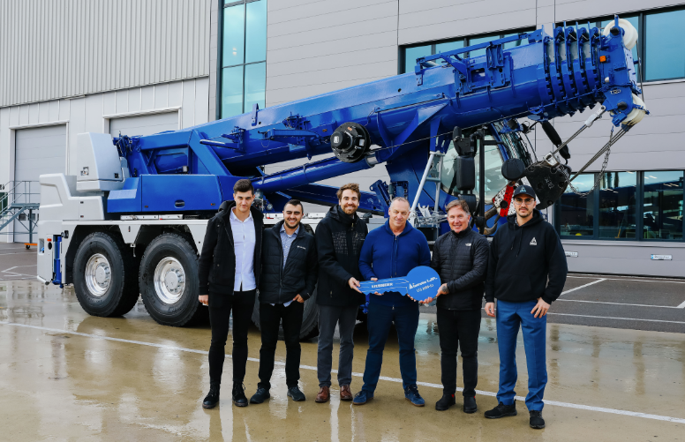

liebherr-ltc1050-3.1-ljp-handover.jpg  
Crane handover in Ehingen: (from left to right) Axel Côté, Maxime Côté, (both LJP), Simon Schuster (Liebherr-Werk Ehingen GmbH), Sylvain Côté (LJP), Lee Spalding (Liebherr Canada), Sebastien Côté (LJP).

**Contact**

Wolfgang Beringer  
Marketing and Communication  
Phone: +49 7391/502 - 3663  
Email: wolfgang.beringer@liebherr.com

**Published by**

Liebherr-Werk Ehingen GmbH  
Ehingen (Donau) / Germany  
www.liebherr.com