Press release

Training at Liebherr: pursuing a new chapter in life with unwavering commitment

⸺

The new 2023/2024 training year has begun

Liebherr is pleased to welcome new talent in various product segments worldwide

Over 400 trainees at Liebherr plants in France and the DACH region

In September, Liebherr welcomed over 400 new trainees at various Group sites in Germany, Austria, Switzerland and France. The range of apprenticeships at Liebherr is wide, but no matter the product segment – whether technical or commercial – skilled young talents are taking the next steps in pursuing a new chapter in their lives. Liebherr offers the ideal environment and conditions for this.

Regardless of the site at which the new training course starts or the career aspirations of the new recruits, the first step is to get to know the Liebherr Group and one another. The induction week therefore began, as usual, with the trainees being welcomed by their trainers and the management board of the respective Liebherr companies.

Diving into the world of Liebherr:

In the first few days, the trainees not only got to know the Liebherr Group’s products, but also their new colleagues. Product demonstrations, classes on organisational topics and a scavenger hunt through the training premises were arranged to help the talented young professionals familiarise themselves with their new environment. The goal of this is to create special memories for each trainee right at the beginning of their training, helping the junior staff to bond and grow as a team. Fun activities such as an outdoor camp, building a raft for a river trip or a visit to a high ropes adventure park create a sense of achievement and strengthen team cohesion. The focus here is on reaching a common goal through creativity, fun and perseverance.

Liebherr is pleased that there are also many women among the new recruits this year, especially in technical professions. Among them is Greta Sohst. She is full of anticipation for what is to come: “I enjoy putting theory into practice. My aspiration to become a mechatronics engineer stems from the fact that I’m interested in and really enjoy practical work. My internship at Liebherr has reinforced what I really want to do. I’m looking forward to this training being an interesting, exciting time.”

With over 140 Liebherr companies around the world, of which 61 are in Germany, Austria, Switzerland and France, the Liebherr world offers a wide range of training and career opportunities for new trainees and for their future careers. In the coming years, the primary aim for them will be to combine technical knowledge with a passion for Liebherr’s extensive product portfolio – so that the Group can continue to set new standards.

The quality of training is a very high priority at Liebherr. The training programme for school leavers includes professions that offer potential for the future. In addition to traditional apprenticeships, which will continue to be highly relevant for Liebherr, the company also provides training to become e-commerce clerks and application developers with a focus on coding, for example. The strong link between theoretical knowledge and practical expertise is also an integral part of everyday operations. This allows the trainees of today to become the skilled workforce of tomorrow.

For trainees, young professionals, experienced professionals and experts, the Group offers numerous opportunities in both traditional and new professional fields. To this day, Liebherr is an entirely family-run company that attaches great importance to sustainable development, stability and reliability as the cornerstones of long-term success. For this reason, employees are also deeply involved with new, future-oriented topics, such as alternative drive systems or digital transformation.

Liebherr offers each and every member of staff the opportunity to bring pragmatism and ingenuity to the diverse tasks in their daily work. Employees are given the freedom to responsibly pursue ambitious goals and create ideal solutions. This is one of the reasons why many employees strongly identify with Liebherr and our products, and often remain loyal to the Group for many years.

Are you also interested in an apprenticeship, a dual study programme or an internship at Liebherr? You can find everything there is to know about careers at Liebherr by visiting the careers portal at: [www.liebherr.com/schueler](http://www.liebherr.com/schueler)

About the Liebherr Group

The Liebherr Group is a family-run technology company with a highly diversified product portfolio. The company is one of the largest construction equipment manufacturers in the world. It also provides high-quality and user-oriented products and services in a wide range of other areas. The Liebherr Group includes over 140 companies across all continents. In 2022, it employed more than 50,000 staff and achieved combined revenues of over 12.5 billion euros. Liebherr was founded in Kirchdorf an der Iller in Southern Germany in 1949. Since then, the employees have been pursuing the goal of achieving continuous technological innovation, and bringing industry-leading solutions to its customers.

Images

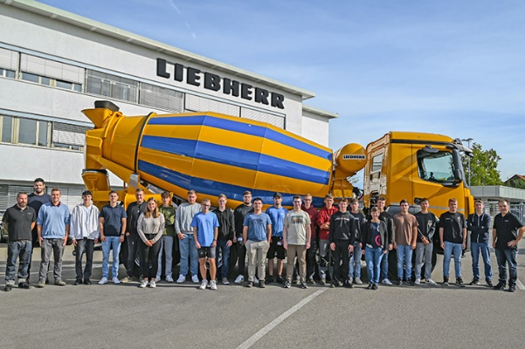

**liebherr-ausbildungsstart-2023-BadSchussenried.jpg**

Liebherr-Mischtechnik GmbH in Bad Schussenried (Germany) expanded its team with 18 dual-study programme students and trainees.

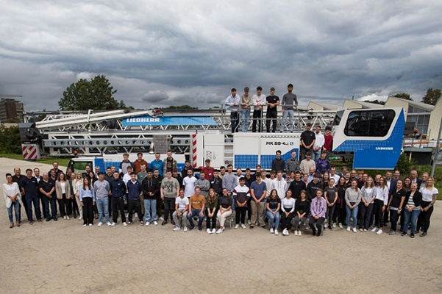

**liebherr-ausbildungsstart-2023-Biberach.jpg**

Some 60 trainees and students have begun their professional journey at Liebherr-Werk Biberach GmbH, Liebherr-Components Biberach GmbH, Liebherr-Baumaschinen Vertriebs- und Service GmbH, Liebherr-Electronic and Drives GmbH and Liebherr-International Deutschland GmbH in Biberach (Germany).

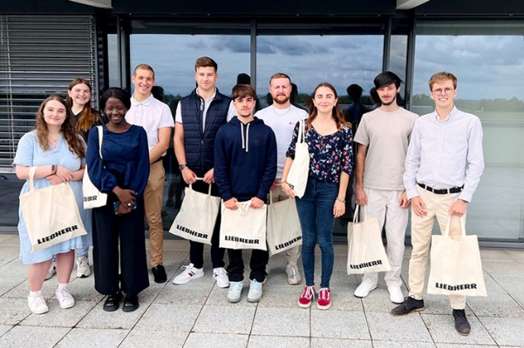

**liebherr-ausbildungsstart-2023-Colmar.jpg**

In France, 18 trainees have begun their careers at Liebherr-Mining Equipment Colmar SAS.

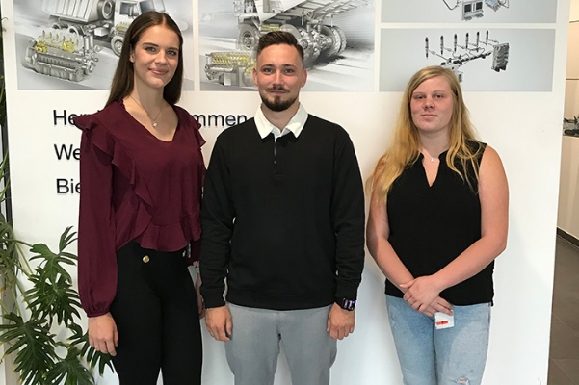

**liebherr-ausbildungsstart-2023-Deggendorf.jpg**

The team at Liebherr-Components Deggendorf GmbH has welcomed three trainees.

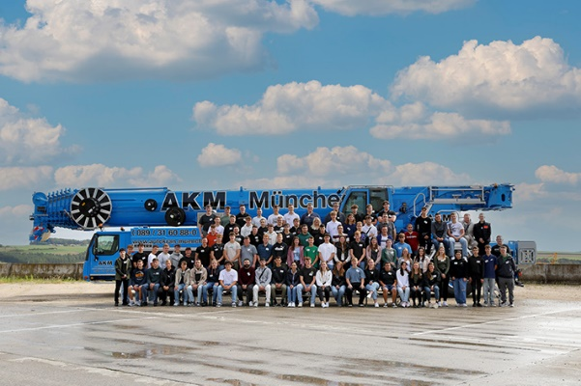

**liebherr-ausbildungsstart-2023-Ehingen.jpg**

With 88 new trainees and students, more young people than ever before have started their professional career at Liebherr-Werk Ehingen GmbH.

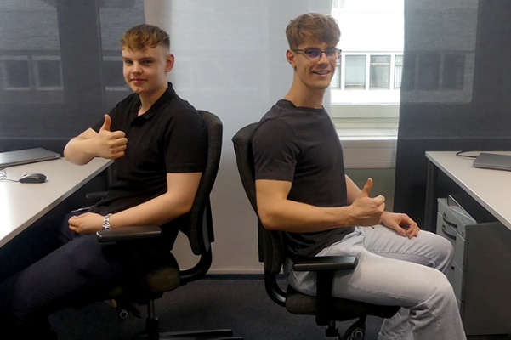

**liebherr-ausbildungsstart-2023-Ettlingen.jpg**

For the first time, Liebherr-Ettlingen GmbH also welcomes two prospective industrial clerks for training.

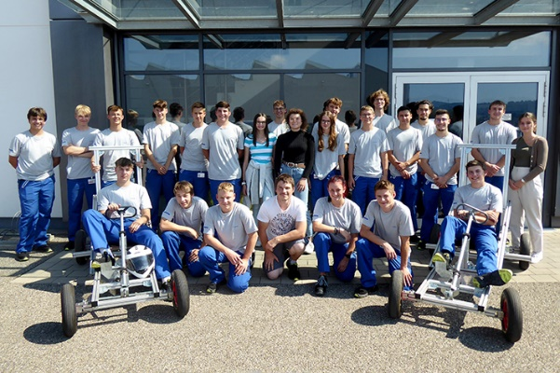

**liebherr-ausbildungsstart-2023-Kempten.jpg**

In Kempten (Germany), 25 new recruits are starting their careers at Liebherr-Verzahntechnik GmbH.

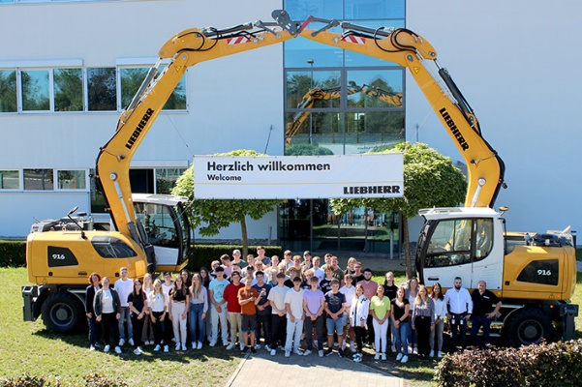

**liebherr-ausbildungsstart-2023-Kirchdorf.jpg**

In Kirchdorf (Germany), 49 young professionals have joined Liebherr-Hydraulikbagger GmbH, Liebherr-Components Kirchdorf GmbH and Liebherr-Logistics GmbH.

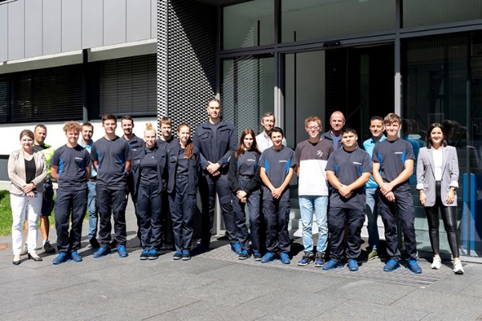

**liebherr-ausbildungsstart-2023-Lienz.JPG**

Liebherr-Hausgeräte Lienz GmbH welcomed 11 new team members in Lienz (Austria).

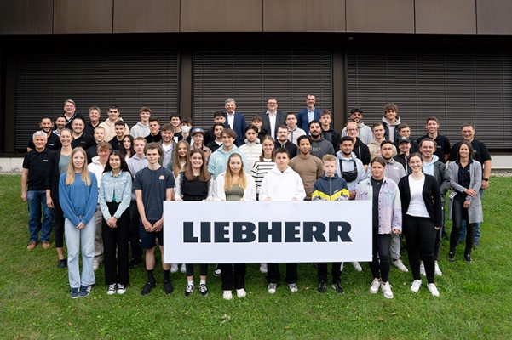

**liebherr-ausbildungsstart-2023-Lindenberg.jpg**

At Liebherr-Aerospace Lindenberg GmbH, the team has grown by 41 new trainees.

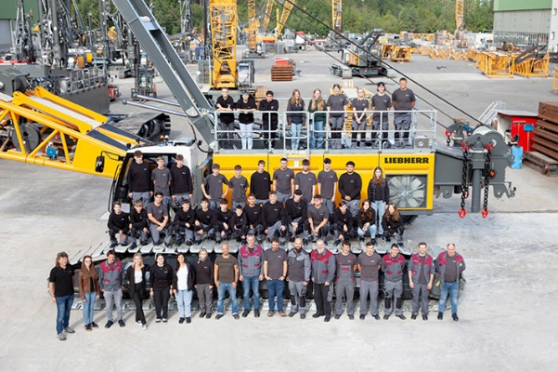

**liebherr-ausbildungsstart-2023-Nenzing.jpg**

In Nenzing (Austria), 34 trainees have begun work at Liebherr-Werk Nenzing GmbH.

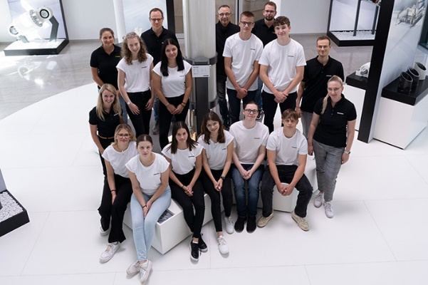

**liebherr-ausbildungsstart-2023-Oberopfingen.jpg**

Eleven young business people and three dual-study programme students started their training at Liebherr-IT Services GmbH, Liebherr-Components Kirchdorf GmbH and Liebherr-Logistics GmbH in Oberopfingen.

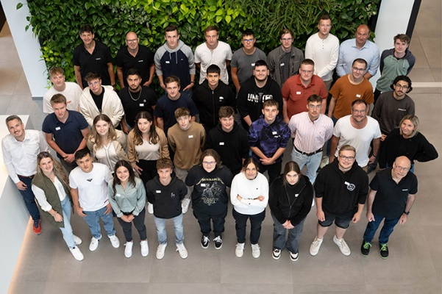

**liebherr-ausbildungsstart-2023-Ochsenhausen.jpg**

Liebherr-Hausgeräte GmbH in Ochsenhausen (Germany) has welcomed 27 young professionals.

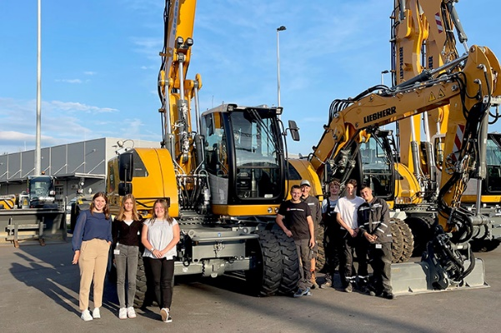

**liebherr-ausbildungsstart-2023-LAT-Puch.jpg**

In Puch bei Hallein (Austria), eight trainees have joined the team at Liebherr Österreich Vertriebs- und Service GmbH.

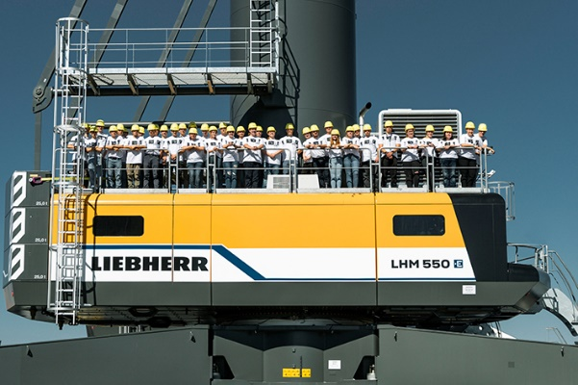

**liebherr-ausbildungsstart-2023-Rostock.jpg**

The Liebherr-MCCtec Rostock GmbH team at the Rostock site (Germany) have 40 new trainees.

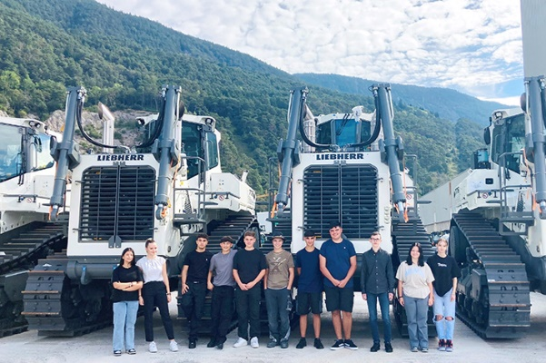

**liebherr-ausbildungsstart-2023-Telfs.jpg**

Liebherr-Werk Telfs GmbH welcomed eleven young industrial and commercial trainees.

Contact

Larissa Lunitz  
Head of Public Relations  
Phone: + 41 79 645 70 67   
Email: larissa.lunitz2@liebherr.com

Published by

Liebherr-International Deutschland GmbH   
Biberach / Germany  
[www.liebherr.com](http://www.liebherr.com)