Press release

XXL Attachment: GMZ 180B is Liebherr's largest clamshell

⸺
GMZ 180B is the largest clamshell yet from Liebherr
XXL dimensions: grab with 8.5 tons total weight and 16 m³ capacity
New Liebherr clamshell for fast loading and unloading operations
Liebherr presents the new GMZ 180B, its largest clamshell to date. The 8.5 tonne attachment is specially designed for coal handling applications. With a capacity of 16 m³, fast loading and unloading processes are guaranteed.
Kirchdorf an der Iller (Germany), 26 October 2023 – Development of the GMZ 180B clamshell was triggered by an order from a customer in Indonesia for four new Liebherr LH 150 C Port Litronic handling machines. In order to manage the high handling volume in its coal mine, the customer was looking for a larger attachment compatible with the LH 150 C Port Litronic handling machines. The new, powerful combination from Liebherr, will enable the customer to load around 200 tonnes of coal into trucks equipped with large dump trailers in just 14 minutes.
New Liebherr clamshell in XXL format
The GMZ 180B grab is specially designed for fast handling of bulk materials. In terms of its dimensions, it is the largest clamshell ever manufactured by Liebherr, with a total weight of 8.5 tonnes and an overall height of 4.7 metres. The bulk shells themselves have a width of 3.2 metres. The capacity of the GMZ 180B is 16 m³ with an opening width of 4.8 metres. In just one loading cycle, large quantities of coal can thus be handled and incoming trucks can be loaded and unloaded more quickly.
GMZ 180B for extra handling capacity in port operations
The GMZ 180B is equipped with large and powerful cylinders that ensure fast opening and closing of the bulk shells and thus fast working speeds. Due to the pump summation of the LH 150 C Port Litronic, the GMZ 180B was given a flow rate of 570 l/min to ensure the cylinders can always be supplied with sufficient hydraulic oil. Thanks to sealed bearings on the cylinders, work is also possible in dirty environments and underwater. To reduce friction in the bearing points, floating bearings were installed. An optional piston rod guard for the hydraulic cylinders is available in addition to the grab itself.
Robust construction and easy maintenance
The bulk shells on the new GMZ 180B are made of solid wear-resistant steel. Thanks to the use of high-quality materials throughout, the grab is extremely stable, durable and thus designed for a long service life. Perfect tolerances and generously dimensioned bearing surfaces result in gentle interactions between the individual components. Regular, automatic lubrication of all lubrication points is carried out by means of an optional central lubrication system.

About the Liebherr Group

The Liebherr Group is a family-run technology company with a widely diversified product range. The company is one of the largest manufacturers of construction machines in the world. However, it also supplies high quality, user-focused products and services in many other sectors. The group currently comprises more than 140 companies based in every continent of the world. In 2022, it had a workforce of over 50,000 and recorded a consolidated total turnover of more than 12.5 billion euros. The company was founded in 1949 in Kirchdorf an der Iller in southern Germany. Since then, its aim has been to win customers by supplying high quality solutions and to contribute to technological progress.

Image
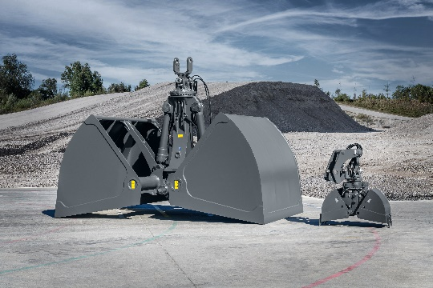
liebherr-gmz180b.jpg
The new GMZ 180B is Liebherr's largest clamshell to date.

Contact
Nadine Willburger
Marketing
Phone: +49 7354 / 80 - 7332
Email: nadine.willburger@liebherr.com

Published by
Liebherr-Hydraulikbagger GmbH
Kirchdorf an der Iller / Germany
www.liebherr.com

