Press release

Liebherr wins ESTA Award in the 'Training' category

⸺

'Training' category recently introduced to underline importance of the topic

Liebherr offers target group-specific training to promote safety in the industry

Digital training formats provide maximum flexibility worldwide

The winners of the ESTA Awards of Excellence 2023 were announced on 20 April at an awards ceremony in Noordwijk, the Netherlands. Liebherr received an award in the 'Training' category for a novel training concept. With a new generation of training offers, Liebherr provides target group-specific training for customers in the crane industry and beyond to support the continuous development of jobs in this industry. The 'Training' category was newly introduced this year by ESTA (European association for the abnormal road transport and mobile crane rental industry) and, for the first time, an award was given for it to underline the importance of this topic.

Ehingen (Donau), (Germany), 10 May 2023 – With a variety of courses in different formats, Liebherr serves the relevant segments for crane operators, dispatchers and workshop personnel around the world. Liebherr's aim is to better train crane industry employees and, in doing so, support safety and accident-free operations in the industry.

Christoph Kleiner, Managing Director Sales at Liebherr-Werk Ehingen GmbH, accepted the award and says: "For us, in addition to training our own employees, training our customers has always been an important component in connection with the safe and efficient use of our cranes while ensuring maximum availability. In recent years, we have added further learning methods, which we consistently used and expanded during the pandemic. These were also aimed at new target groups, not just crane drivers. Overall, training is also a key pillar of our business model, both in terms of presence in our division's training centres worldwide, but also digitally within our MyLiebherr customer platform."

Christoph Behmüller, head of the training department at Liebherr in Ehingen, adds: "Finding skilled workers and, at the same time, developing and retaining them is becoming increasingly more difficult. This is exactly where we want to support our customers in our long-standing partnership. Together we have thought about how we can properly support them in developing their employees. A new concept has been developed in this way. This allows us to offer our customers the possibility of training their employees from beginners to experts. Three areas of professional training have emerged: Mobile crane operators, dispatchers and workshop personnel."

For each target group, Liebherr offers a digital e-learning course that provides a basic introduction to cranes. Through these e-learning courses, a uniform level of knowledge is achieved for the following courses. "This way, we support the development process from career changer to expert – optimally and individually. During practical training weeks in the training departments worldwide, crane class-specific equipment and controls can be studied in depth after successful completion of the e-learning courses. This means that the training groups are on the same level and are already able to exchange a lot of knowledge with each other," says Behmüller.

Liebherr is thus creating a new standard in the crane industry: one that focusses on qualified personnel who are aware of the responsibility that comes with handling and operating mobile cranes. This advances the goal of zero accidents in the industry. Comprehensive offers are available for our crane operators, dispatchers and workshop personnel target groups.

**E-learning – being mobile**

With its e-learning courses, Liebherr offers tailored learning at any time and from anywhere. The learning units can be worked through independently and flexibly. This offers maximum flexibility for all target groups with ultimately the same level of knowledge.

**Face-to-face training courses**

Face-to-face training is a valuable part of Liebherr's training programme. In theoretical and practical sessions, highly qualified and certified trainers explain the complex crane technology using cutaway models, demonstration objects, training cranes and with the help of multimedia. Face-to-face training is offered worldwide in various Liebherr training centres or at customer sites in some cases.

**Live streaming**

The training programme has been expanded to include a wide range of online opportunities for live course participation. These digital solutions make it possible to attend courses via live streaming regardless of where you are, saving valuable resources while still ensuring the highest industry standards and knowledge transfer.

**About Liebherr-Werk Ehingen GmbH**

Liebherr-Werk Ehingen GmbH is a leading manufacturer of mobile and crawler cranes. Its range of mobile cranes extends from 2-axle 35 tonne cranes to heavy duty cranes with a lifting capacity of 1200 tonnes and a 9-axle chassis. Its lattice boom cranes on mobile or crawler crane chassis deliver lifting capacities of up to 3000 tonnes. With universal boom systems and extensive additional equipment, they can be seen in action on construction sites throughout the world. The Ehingen site has a workforce of 4,300. Extensive, global service guarantees the high availability of Liebherr mobile and crawler cranes. In 2022, the Liebherr plant in Ehingen recorded a turnover of 2.37 billion euros.

**About the Liebherr Group**

The Liebherr Group is a family-run technology company with a highly diversified product portfolio. The company is one of the largest construction equipment manufacturers in the world. It also provides high-quality and user-oriented products and services in a wide range of other areas. The Liebherr Group includes over 140 companies across all continents. In 2022, it employed more than 50,000 staff and achieved combined revenues of over 12.5 billion euros. Liebherr was founded in Kirchdorf an der Iller in Southern Germany in 1949. Since then, the employees have been pursuing the goal of achieving continuous technological innovation, and bringing industry-leading solutions to its customers.

**Images**

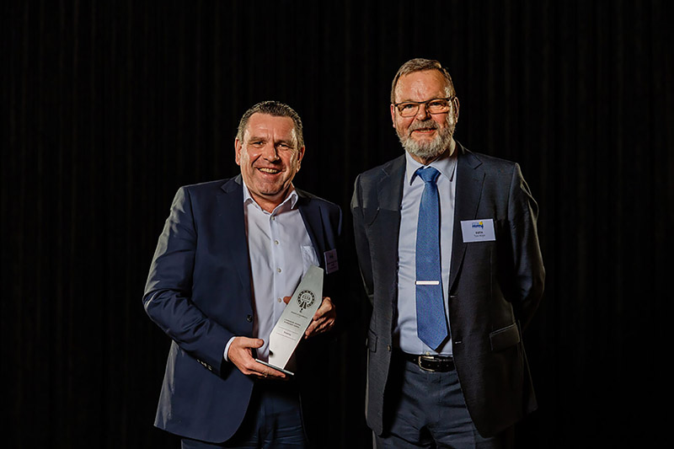

esta-awards-2023-liebherr-training.jpg  
Christoph Kleiner, Head of Sales at Liebherr-Werk Ehingen GmbH, accepts the ESTA Award from ESTA Director Ton Klijn.

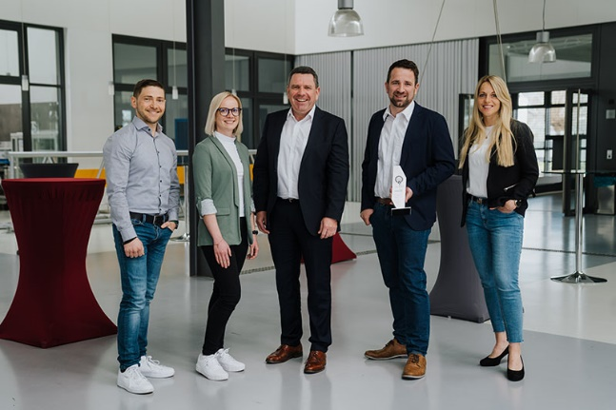

esta-awards-2023-liebherr-training-centre.jpg  
Training Manager Christoph Behmüller accepts the ESTA Award on behalf of the entire Liebherr training team in Ehingen from Managing Director Christoph Kleiner. From left to right: Robert Lorenz, Jessika Kleinert, Christoph Behmüller, Christoph Kleiner, Michaela Gogeissl.

Contact

Wolfgang Beringer  
Marketing and Communication  
Phone: +49 7391/502-3663  
Email: wolfgang.beringer@liebherr.com

Published by

Liebherr-Werk Ehingen GmbH  
Ehingen (Donau) / Germany  
[www.liebherr.com](http://www.liebherr.com)