Press information

Liebherr 250 EC-B crane on gantry helps renovate historic church

⸺

Tricky ground conditions require special solution by Tradler-Baumaschinen and Liebherr

250 EC-B delivers optimal performance on site with a 65-metre jib and a lifting capacity of up to 12 tonnes

Reliable service with experienced technicians completes the package

Renovation work set against a stunning mountain backdrop: a Liebherr 250 EC-B 12 flat-top crane is currently carrying out much needed work in Bad Reichenhall, Germany, where the 12th-century listed parish church of St. Zeno is undergoing renovations. One of the project’s challenges lies in the difficult ground conditions around the church. Tradler-Baumaschinen and Liebherr developed a suitable solution to ensure successful crane operation.

Bad Reichenhall (Germany), 31 May 2023 – How and where should the top-slewing crane be placed to ensure optimal progress at the parish church site? These questions presented experts from Tradler-Baumaschinen and Liebherr with a tough but workable challenge. The problem lay in the fact that the church is surrounded by a cemetery, meaning that the ground lacks stability. As well as this, it was only possible for the crane and its substructure to be positioned on paths running between graves.

The solution involved the use of a gantry, a steel construction that allows the space under the crane to be freely accessible. A concrete foundation featuring cement grout-injected micropiles was set and the 6 x 6 metre gantry was then positioned on top. The micropiles measure less than 30 centimetres in diameter, making it possible to use relatively small and lightweight drilling equipment. Only the paths have foundations set in them – the graves remain untouched. A mobile crane subsequently mounted a 250 EC-B flat-top crane with a 21 HC tower system and undercarriage on the gantry. This concept provides the crane with stability and allows it to work above the graves.

Trusted partnership

As always, Tradler-Baumaschinen and Liebherr can fully rely on each other for this project. “Liebherr and Tradler-Baumaschinen have enjoyed a successful and trusted partnership for decades,” says Konrad Kracher, sales representative at Tradler-Baumaschinen GmbH. “We have an experienced regional Liebherr dealer in Tradler-Baumaschinen, one who has been providing our customers with a reliable and custom-fit service for decades," says Alexander Beck, Area Sales Manager at Liebherr-Werk Biberach GmbH.

Tradler-Baumaschinen hired out the crane for the renovation work and is also the responsible service partner. Assembly was straightforward because, like its brothers in the series, the 250 EC-B has impressive features when it comes to assembly and transport. LiConnect quick connectors, for example, make it easy to attach the jib and counter-jib to the compact head with slewing platform, cabin, and switchgear cabinet.

The 250 EC-B being used at Bad Reichenhall has a hook height of just under 51 metres and a 65-metre-long jib. The top-slewing crane can lift up to 2,850 kilograms at its jib head and offers a maximum lifting capacity of twelve tonnes. Intelligent assistance systems such as Micromove are there to help the crane operator place building materials smoothly and with precision. This is particularly relevant for work on the listed church, so that damages can be prevented from occurring.

Perfect partner for a variety of lifts

The church’s renovation is expected to last for about a year with the crane set to be dismantled in spring 2024. During this time, the tower crane will assist with multiple tasks. To start with, it will help with assembling scaffolding and a temporary roof system. As work on site progresses, the top-slewing crane will remove part of the protective roof each day so that materials can be moved inside the roof truss. Because the existing roof truss is being reinforced with structural steelwork, heavy steel elements and other building materials will need to be moved frequently.

About Tradler-Baumaschinen

Tradler-Baumaschinen GmbH is a reliable partner, who supports customers through the provision of construction machinery, construction equipment, and services. The medium-sized, owner-managed company has its base in Traunstein-Wolkersdorf (Germany) and has been a successful Liebherr dealer for over 40 years. Sales, service and rental: Tradler-Baumaschinen offers numerous building construction and civil engineering services all under one roof. Its range of Liebherr tower cranes covers all size classes, from fast-erecting cranes to flat-top and high-top cranes.

About the Liebherr Tower Cranes Division

More than seven decades of experience have made Liebherr a recognised specialist for lifting technology on all types of construction sites. The range of Liebherr Tower Cranes encompasses an extensive selection of high-quality tower cranes that are used worldwide. This includes fast-erecting, top-slewing, luffing jib and special-purpose cranes as well as mobile construction cranes. In addition to these products, Liebherr also offers a wide range of services that complete the company’s portfolio: Tower Crane Solutions, the Tower Crane Center and Tower Crane Customer Service.

About the Liebherr Group

The Liebherr Group is a family-run technology company with a highly diversified product portfolio. The company is one of the world's largest manufacturers of construction machinery. It also offers high-quality, user-oriented products and services in multiple other areas. Today, the group consists of more than 140 companies across all continents. In 2022, it employed more than 50,000 people and achieved combined revenues of over 12.5 billion euros. Liebherr was founded in 1949, in Kirchdorf an der Iller in southern Germany. Ever since then, the company’s employees have been committed to satisfying customers with advanced solutions and to helping drive technological progress.

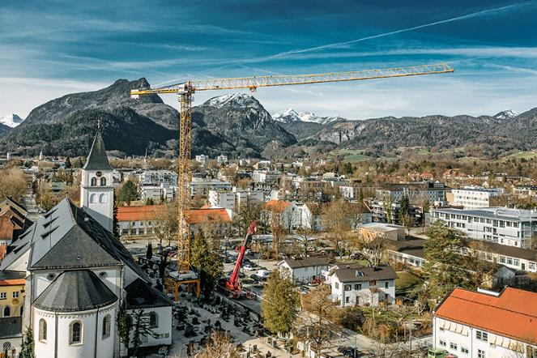Image

liebherr-250-ec-b-bad-reichenhall-2023.jpg  
The Liebherr 250 EC-B stands on a six-metre-high gantry, meaning that it can work on a solid base above the graves.

Contact

Daniel Haefele  
Global Communication  
Phone: +49 7351 / 41 - 2330  
Email: daniel.haefele@liebherr.com

Published by

Liebherr-Werk Biberach GmbH  
Biberach / Germany  
www.liebherr.com