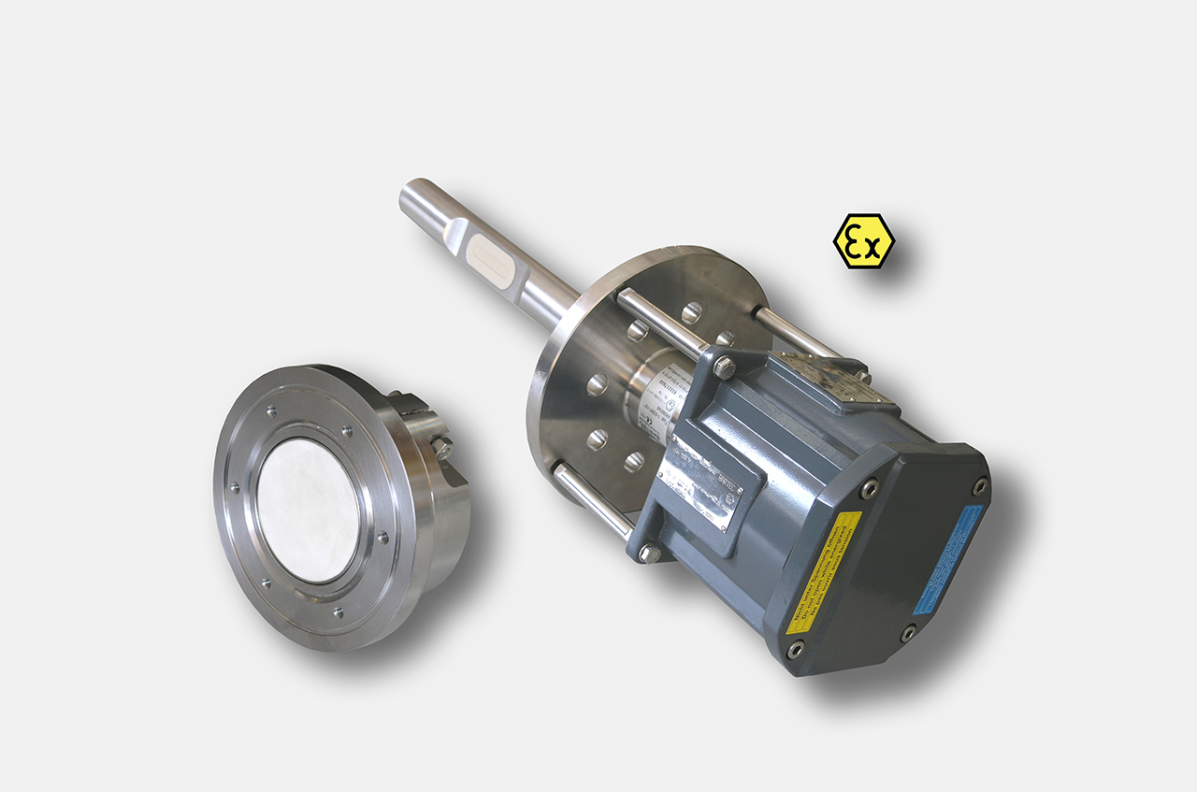
Questionnaire
Liebherr water content measurement system WMS

Company: |  | Contact:
Address: |  | www.:
Phone: |  | E-Mail:
Branch: |  | Date:

Medium characteristics:

Marking  Medium/liquid: | other emulsion:  Composition:
Medium temperatur (°C) | min.: norm.: max.:
Ambient temperature (°C) | min.: norm.: max.:
Pressure (bar) | min.: norm.: max.:
Density (kg/m³): | min.: norm.: max.:  Variation:
Viscosity (Pas) | min.: norm.: max.:

Water content reference: min: % water content max: % water content
Water saturation at: ca. % water content
Measuring range, water content: +/- % water content

Rate of wear: low high
Adhesive strength: low high
Conductivity: yes no
Moisture reference (% water content):

Installation situation / Measuring point:
Sensor installation place: Tube size, ∅: mm, or “
Wall thickness: mm
tank highness: m
∅ : m

other installation site:

Quick Change / retractable fitting necessary: yes no

Distance measuring point (s) – PLC/Controll-system, max: m

Number of measuring points:

Required EX-protection classification:

Separate indication- and parameterization module necessary:

OTHER:

Process connection: 2“ ANSI 600

Output signal : 4 - 20 mA active supplied with sensor network,
max. load 500 Ohms, resolution 12 bit

Option: Standard-HART-Protocol

Power supply: 24 V DC (15...36 VDC) 150 mA DC

Short description of the plant or description of the process cycle around the measuring point:

