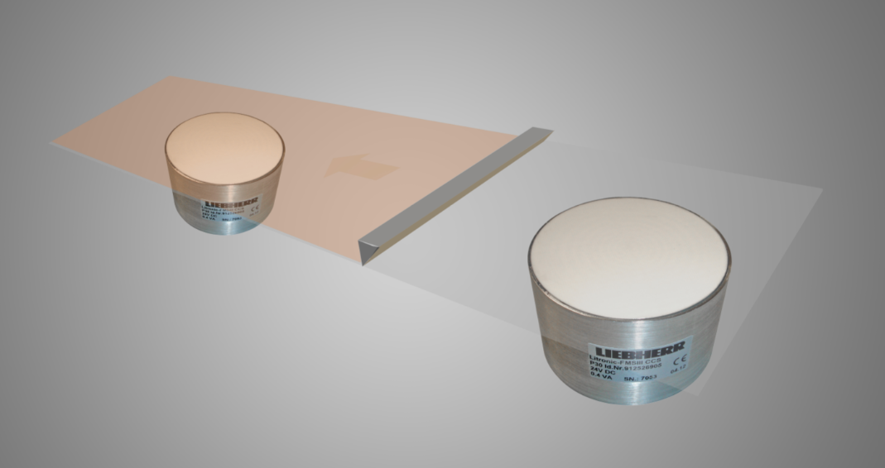

Questionnaire
Liebherr Online Coating Thickness Measurement /
weight per unit are definition type Litronic FMS III / CCS

Company: |  | Contact person:
Adress: |  | www.
Phone: |  | E-Mail:
Branch: |  | Date:

Basic material: Click here to enter a text
Basis material thickness +- %
stable ☐ unstable ☐
Lamination: yes ☐ no ☐
Material: Click here to enter a text
Lamination Thickness up to
Moisture content from up to %
Weight proportion: %
Per cent by volume:%

Solvent: yes ☐ no ☐
Using only in EX-free areas

Belt width: Click here to enter a text
Belt speed: Click here to enter a text
Measurement: with contact ☐ contactless ☐
Measurement unit: Click here to enter a text
Material temperature: Click here to enter a text
Ambient temperature: Click here to enter a text

Installation place: Click here to enter a text
Number of measuring points: Click here to enter a text
Short description of the plant or description of the process cycle around the measuring point:
Click here to enter a text

