Liebherr online coating thickness measurement/

weight per unit and definition type Litronic FMS-CCS

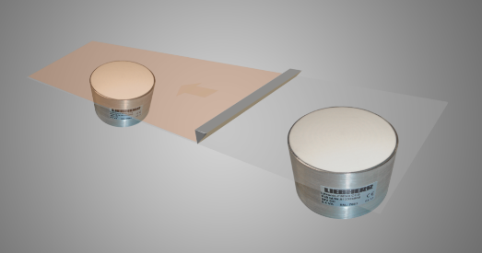

|  |  |  |  |
| --- | --- | --- | --- |
| **Company**: |  | **Contact person:** |  |
| **Adress:** |  | **www**: |  |
| **Phone:** |  | **E-Mail:** |  |
| **Branch:** |  | **Date:** |  |

**Basic material:**        
**Basis material thickness**   **+-** **%**

**stable  unstable**

**Lamination:** **yes  no**

**Material:**

**Lamination Thickness**  **up to** 

**Moisture content from**  **up to** **%**

**Weight proportion:** **%**

**Per cent by volume:****%**

**Solvent: yes  no**

**Using only in EX-free areas**

**Using only in EX-free areas**

**Belt width:**

**Belt speed:**

**Measurement: with contact  contactless**

**Measurement unit:**

**Material temperature:**

**Ambient temperature:**

**Installation place:**

**Number of measuring points:**

**Short description of the plant or description of the process cycle around the measuring point:**