Questionnaire WMS II   
Liebherr water content measurement system WMS II

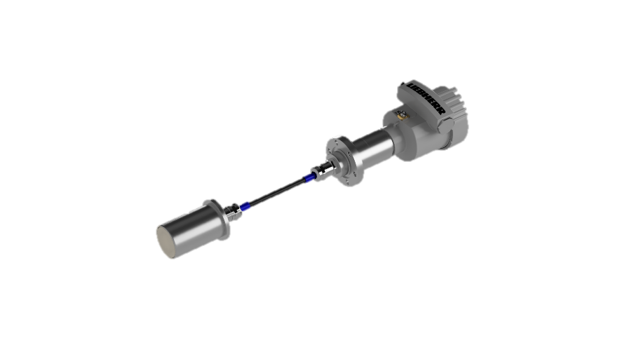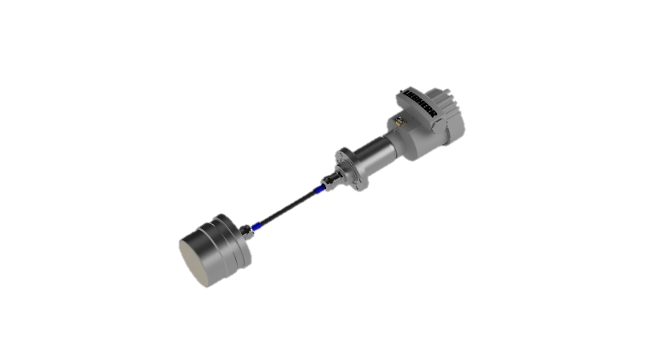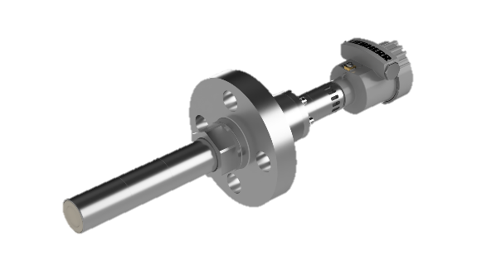

**WMS II planar sensor P45-GD WMS II planar sensor P78-GD WMS II rod sensor P45-GD**

|  |  |  |  |
| --- | --- | --- | --- |
| **Company:** |  | **Contact:** |  |
| **Street:** |  | **Post code, Town:** |  |
| **Phone:** |  | **E-Mail:** |  |
| **www.** |  | **Date:** |  |

**Process and medium characteristics:**

|  |  |
| --- | --- |
| **Marking Medium/Liquid:** | other emulsion:  Composition: |
| **Marking Powder & Bulk:** | Other Powder&Bulk:  Grain size:min:    mm max:    mm |
| **Medium/Material  temperature** (°C) | min.:    norm.:     max.: |
| **Ambient temperature** (°C) | min.:    norm.:     max.: |
| **Pressure** (bar) | min.:    norm.:     max.: |
| **Density (**kg/m³)**:** | min.:     norm.:      max.:  Variation: |
| **Viscosity** (Pas) | min.:    norm.:     max.: |

**Measurement range  
Water content/Moisture:**  min:      % water content/moisture max:      % water content/moisture

**Required accuracy:** +/-      % water content/moisture

Water saturation at: ca.     % water content   
  
Rate of wear:  low  high

Adhesive strength:  low  high

Conductivity:  yes  no

Moisture reference (% water content):

**Installation Place / measurement point:**

**Sensor installation place**   
**Emulsions:**  Tube size, :       mm, or    Inch “

Wall thickness:       mm   
  
  Tank highness:       m

:       m

Other installation site:      

**Measuring field shaft sensor:**  front side  Option: lateral measuring field

**Retractable fitting** (only shaft sensor, up to pressure 6 bar,  
material: 1.4571) desired:  yes  no

**Installation place  
Powder &Bulk:**  Tube :       mm

Other

Process type:  Continuous operation  Batching operation (Starting signal 24 V)

Material layer on sensor: min:       mm max:       mm

**Material Sensor:**  other material:

**Distance measuring point (s) – PLC/Controll-system**, max:       m

**Number of measuring points:**       

**Separate display necessary:**

**Certificates**: ATEX / UKEX:

EU-type examination certificate number: EPS 21 ATEX 1 140 X

EPS 22 UKEX 1 159 X



EN IEC 60079-0:2018, EN 60079-1:2014, EN 60079-11:2012,   
EN 60079-26:2015, EN 60079-31:2014

**Ein Bild, das Screenshot, Schwarz, Grafiken, Design enthält.
**Ein Bild, das Text, Schild, gelb enthält.
**Gas EX-protection:**

II 1/2 G Ex db/ia IIC T4 Ga/Gb

**Dust EX-protection:**

Ein Bild, das Text, Schild, gelb enthält.
II 1/2 D Ex tb/ia IIIC T135°C Da/Db

IECEx:

Certificate number: IECEx EPS 21.0047X

IEC 60079-0:2017 Edition: 7.0, IEC 60079-1:2014-06 Edition: 7.0,   
 IEC 60079-11:2011 Edition: 6, IEC 60079-26:2014-10 Edition: 3.0,   
 IEC 60079-31:2013 Edition: 2

**Gas EX-protection:**

Ex db/ia IIC T4 Ga/Gb

**Dust EX-protection:**

Ex tb/ia IIIC T135°C Da/Db

**Desired applicable device category:**

**Other local certificates necessary**:

Other:

**Process connection**: Pressure: 75 bar (16 bar with WMS II planar sensor P78-GD)

Threaded flange: ASME B16.5

Temperature class: 1500

Flange: DN 40 or 1 ½ Zoll

Other process connection necessary:

**Output signal:** 4 - 20 mA, actively supplied from sensor

power supply unit, max. load 500 Ω, resolution 16 bit

HART-Protocol

Power supply: 12 V DC (SELV/PELV)

Short description of the plant/description of the process cycle around the measuring point/ other information: